
Empowerment through quality technical education
AJEENKYA DY PATIL SCHOOL OF ENGINEERING
Imparting quality education in the field of Artificial Intelligence and Data science.
Department of Artificial Intelligence & Data Science Engineering
Dr. D. Y. Patil Knowledge City, Charholi (Bk), Lohegaon, Pune – 412 105
IQAC/12a

LAB MANUAL

ARTIFICIAL INTELLIGENCE LABORATORY (PCC-205-AID)
SE (AI&DS) 2024 COURSE

Course Coordinator
Prof. Priyanka S. Bhore

DEPARTMENT OF
ARTIFICIAL INTELLIGENCE & DATA SCIENCE
Department of Artificial Intelligence & Data Science
Vision:
Imparting quality education in the field of Artificial Intelligence and Data Science
Mission:
- To include the culture of R and D to meet the future challenges in AI and DS.
- To develop technical skills among students for building intelligent systems to solve problems.
- To develop entrepreneurship skills in various areas among the students.
- To include moral, social and ethical values to make students best citizens of country.

Program Educational Outcomes:
- To prepare globally competent graduates having strong fundamentals, domain knowledge, updated with modern technology to provide the effective solutions for engineering problems.
- To prepare the graduates to work as a committed professional with strong professional ethics and values, sense of responsibilities, understanding of legal, safety, health, societal, cultural and environmental issues.
- To prepare committed and motivated graduates with research attitude, lifelong learning, investigative approach, and multidisciplinary thinking.
- To prepare the graduates with strong managerial and communication skills to work effectively as individuals as well as in teams.
Program Specific Outcomes:
- PSO1: Demonstrate proficiency in essential concepts of computer science and data science and programming solutions.
- PSO2: Formulate robust software design, execution, and testing strategies employing a soft- ware paradigms and Artificial Intelligence knowledge to solve real word problems.
- PSO3: To create, and apply the techniques of AI and Data Science to forecast future events in the domain of Healthcare, Education, and Agriculture, Automation , Transport etc

Table of Contents
Contents

1. Guidelines to manual usage 4
2. Laboratory Objective 10
3. Laboratory Equipment/Software 10
4. Laboratory Experiment list 10
4.1. Experiment No. 1 11
4.2. Experiment No. 2 17
4.3. Experiment No. 3 26
4.4. Experiment No. 4 33
4.5. Experiment No. 5 39
4.6. Experiment No. 6 47
4.7. Experiment No. 7 55
4.8. Experiment No. 8 59
4.9. Experiment No. 9 63
4.10. Experiment No. 10 67
5. Appendix.........................................................................................................................................74

Guidelines to manual usage
This manual assumes that the facilitators are aware of collaborative learning methodologies.
This manual will provide a tool to facilitate the session on Artificial Intelligence modules in collaborative learning environment.
The facilitator is expected to refer this manual before the session.

Icon of Graduate Attributes
K  Applying Knowledge | A  Problem Analysis | D  Design & Development | I  Investigation  of problems
M  Modern Tool  Usage | E  Engineer  &  Society | E  Environment Sustainability | T  Ethics
T  Individual &  Team work | O  Communication | M  Project Management  & Finance | I  Life-Long Learning

Blooms Taxonomy
Bloom’s Taxonomy is a classification of the different objectives and skills that educators set for their students (learning outcomes).

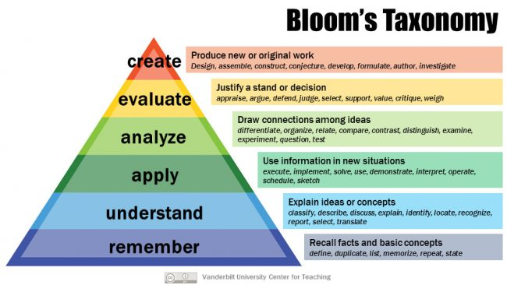

Program Outcomes:
Program Outcomes are statements that describe what students are expected to know and be able to do upon graduating from the program. These relate to the skills, knowledge, attitude and behaviour that students acquire through the program. On successful completion of B.E. in Artificial Intelligence and Data Science, graduating students/graduates will be able to:
PO1 | Engineering knowledge | Engineering Knowledge: Apply knowledge of mathematics, natural science, computing, engineering fundamentals and an engineering specialization as specified in WK1 to WK4 respectively to develop to the solution of complex engineering  problems.
PO2 | Problem analysis | Problem Analysis: Identify, formulate, review research literature and analyze complex engineering problems reaching substantiated conclusions with consideration for sustainable  development. (WK1 to WK4)
PO3 | Design / Development of Solutions | Design/Development of Solutions: Design creative solutions for complex engineering problems and design/develop systems/components/processes to meet identified needs with consideration for the public health and safety, whole-life cost, net zero carbon, culture, society and environment as required.  (WK5)
PO4 | Conduct Investigations of Complex Problems | Conduct investigations of complex engineering problems using research-based knowledge including design of experiments, modelling, analysis & interpretation of data to provide valid  conclusions. (WK8).
PO5 | Engineering Tool Usage | Create, select and apply appropriate techniques, resources and modern engineering & IT tools, including prediction and modelling recognizing their limitations to solve complex  engineering problems. (WK2 and WK6)
PO6 | The Engineer and The World | Analyze and evaluate societal and environmental aspects while solving complex engineering problems for its impact on sustainability with reference to economy, health, safety, legal  framework, culture and environment. (WK1, WK5, and WK7).
PO7 | Ethics | Apply ethical principles and commit to professional ethics, human values, diversity and inclusion; adhere to national &  international laws. (WK9)

PO8 | Individual and Collaborative Team  work: | Function effectively as an individual, and as a member or leader in diverse/multi-disciplinary teams.
PO9 | Communication | Communicate effectively and inclusively within the engineering community and society at large, such as being able to comprehend and write effective reports and design documentation, make effective presentations considering  cultural, language, and learning differences
PO10 | Project Management and Finance | Apply knowledge and understanding of engineering management principles and economic decision-making and apply these to one’s own work, as a member and leader in a team, and to manage projects and in multidisciplinary  environments.
PO11 | Life-Long Learning | Recognize the need for, and have the preparation and ability for  i) independent and life-long learning ii) adaptability to new and emerging technologies and iii) critical thinking in the broadest context of technological change. (WK8)

Course Name: Artificial Intelligence Laboratory
Course Code: PCC-205- AID
Course Outcomes:
  - CO1: Apply rule-based systems and search algorithms (BFS, DFS, A*) to solve structured problem-solving tasks.
  - CO2: Design and implement solutions for constraint satisfaction problems using backtracking and constraint propagation.
  - CO3: Develop intelligent agents for decision-making in games using Minimax and Alpha-Beta Pruning techniques.
  - CO4: Construct and analyze basic neural network models for classification tasks, including the use of activation functions.

CO to PO Mapping:

CO / PO | PO1 | PO2 | PO3 | PO4 | PO5 | PO6 | PO7 | PO8 | PO9 | PO10 | PO11
CO1 | 3 | 3 |  |  | 3 | 2
CO2 | 3 | 3 | 3 |  | 3
CO3 | 3 | 3 | 3 |  | 3 | 2
CO4 | 3 | 3 | 3 | 3 | 3

CO to PSO Mapping:

CO / PSO | PSO1 | PSO2 | PSO3
CO1 | 3 | 2
CO2 | 3 | 3
CO3 | 3 | 3
CO4 | 3 | 2 | 2

2. Laboratory Objective
- To introduce fundamental concepts and techniques in Artificial Intelligence.
- To enable students to implement key AI algorithms for search, reasoning, and learning.
- To develop practical skills in solving real-world problems using AI.
- To provide foundational knowledge in neural networks and decision-making systems.

3. Laboratory Equipment/Software
Category | Requirements
Hardware | Intel(R) Core(TM) i7-6700T CPU @ 2.80GHz 2.81 GHz
OS | Windows 10
Language | Python 3.8+
IDE | PyCharm / Jupyter Notebook
AI Tools | ChatGPT, SORA, AI Image Generators
Internet | Required

4. Laboratory Experiment list
Sr. | Practical Assignments
1 | Building an Expert System Using Rule-Based Systems - Objective: Develop an Expert  System that provides simple decision-making.
2 | Implementing AI Search Algorithms (BFS & DFS) - Maze Solver  Objective: Solve AI search problems using Graph Search Algorithms.
3 | Implementation of A* algorithm Objective: Solve AI search problems using Graph Search  Algorithm.
4 | Implement a solution for Constraint Satisfaction Problem (CSP) Objective: To implement  a CSP-based solution for solving real-world problems like Map Coloring, Sudoku, or Timetable Scheduling using backtracking with constraint propagation.
5 | Implementing Minimax Algorithm Objective: Understand and implement the basic  Minimax algorithm for two-player deterministic games.
6 | Minimax with Alpha-Beta Pruning Objective: Enhance Minimax using Alpha-Beta pruning  to reduce computation time.
7 | Assignment and practice of ChatGPT and its usage
8 | Assignment and practice of SORA
9 | Assignment and practice of AI Image Generator
10 | Assignment and practice of Prompt Engineering to craft effective prompts.

Experiment No. 1
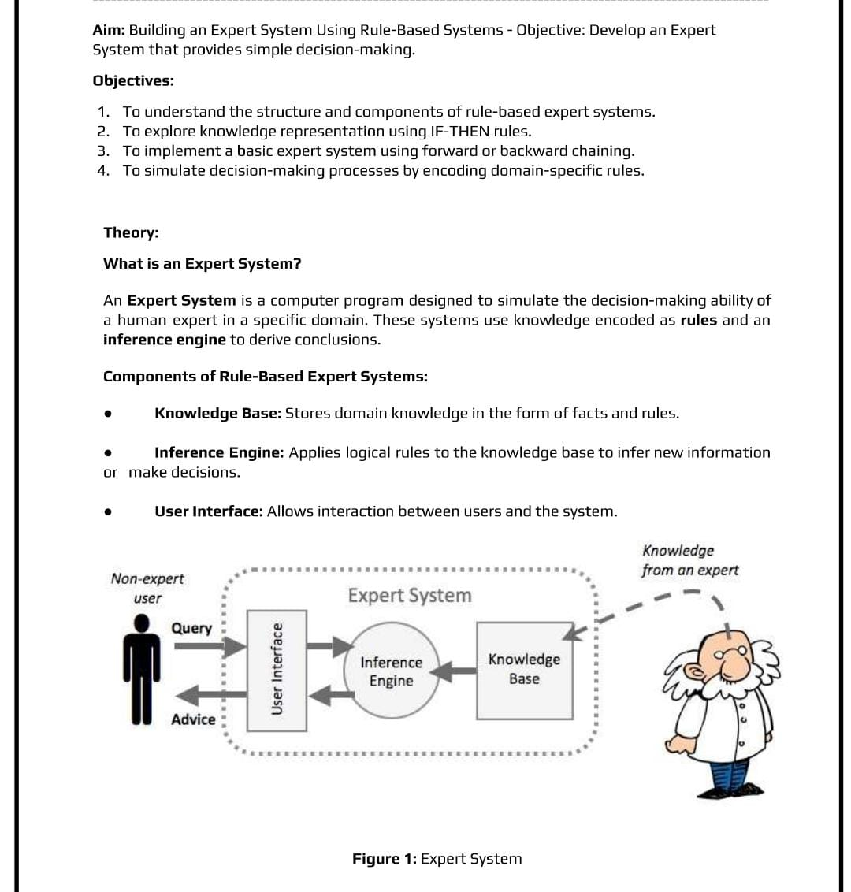
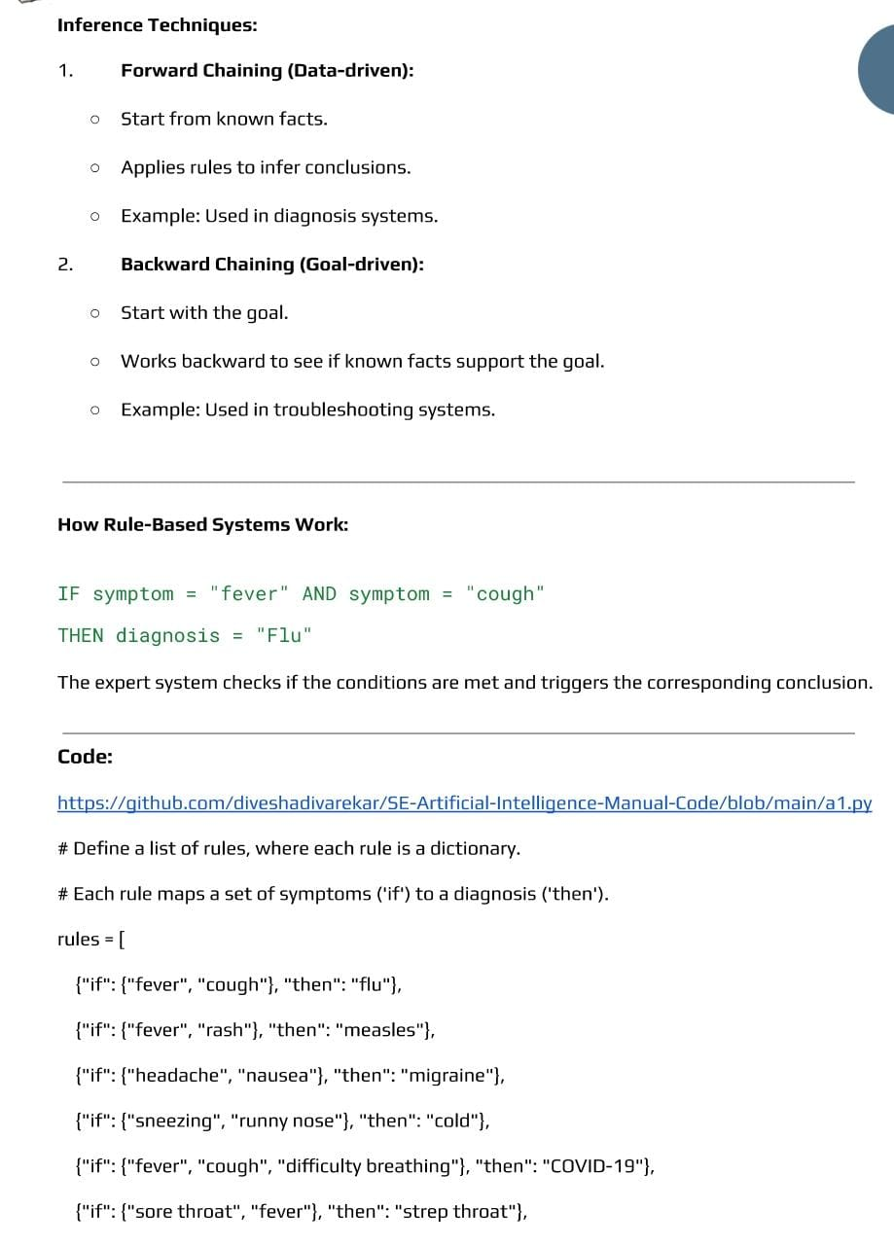

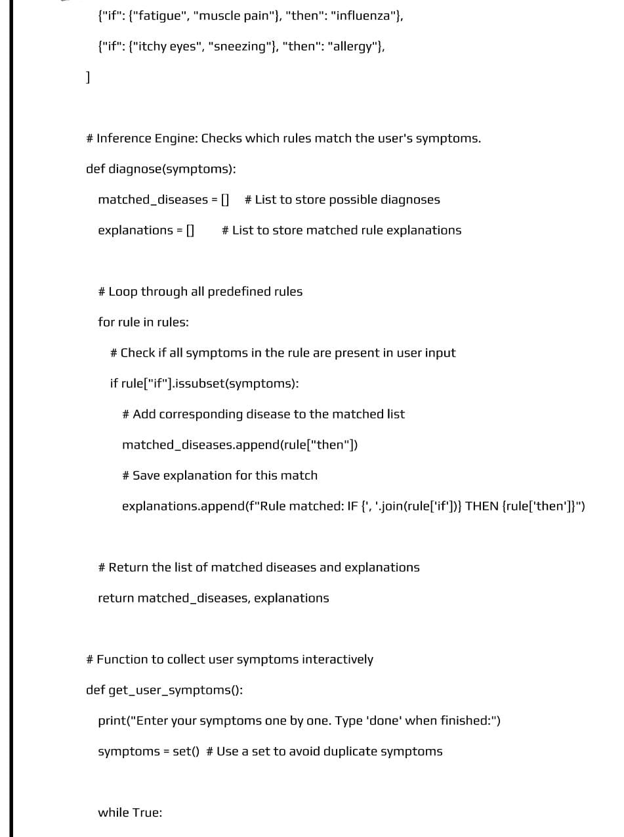

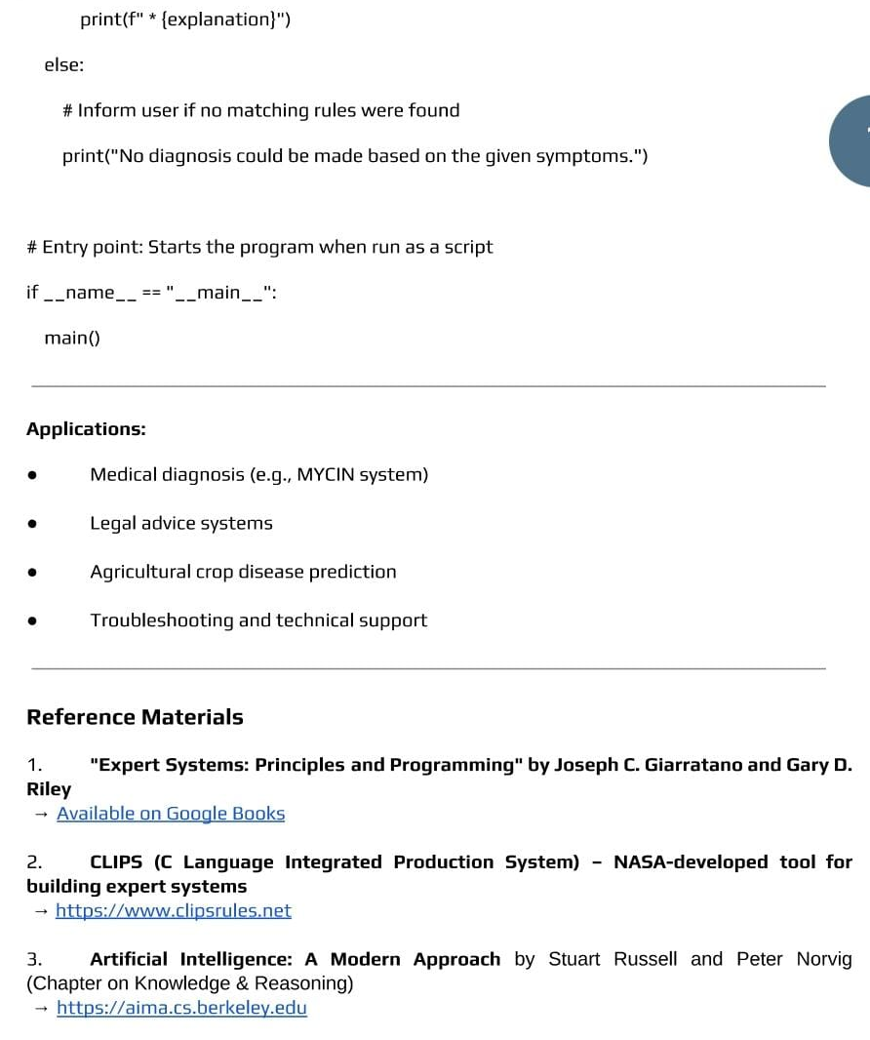

Input: Enter your body temperature: 80
Output: You have mild fever.
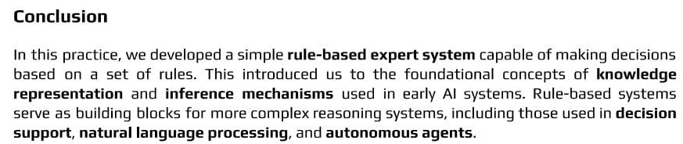
Outcome:
Upon completion of this experiment, students will be able to:
ELO1: Create a well-organized set of rules and a proper reasoning method so the expert system can make correct decisions on its own.
ELO2: Build an expert system that can apply rules, reason step-by-step, and give accurate answers.
ELO3: Test and improve the expert system by checking if the rules work correctly, fixing mistakes, and making the system faster and more reliable.
Questions:
• What is an Expert System?
• What is a rule-based system?
• What are IF–THEN rules in an Expert System?
• What is the function of the inference engine?
• Give one example of a simple rule-based Expert System.

Experiment No. 2
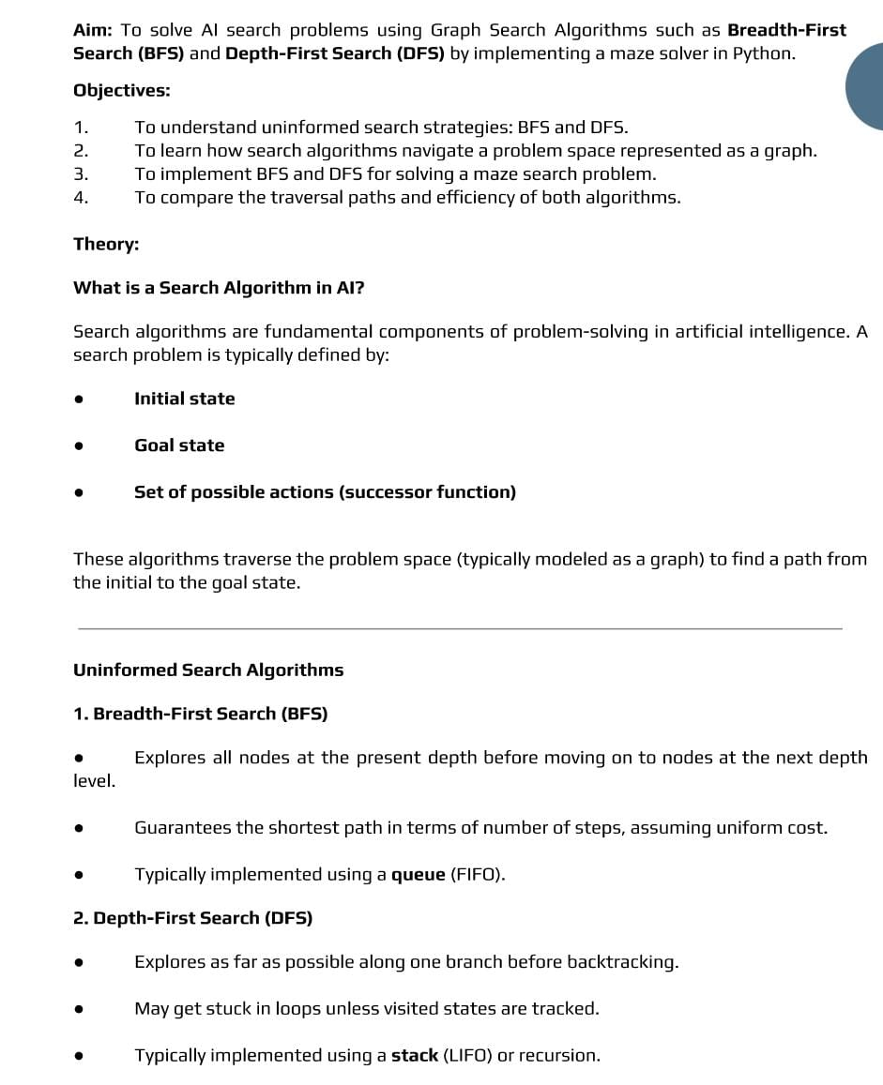

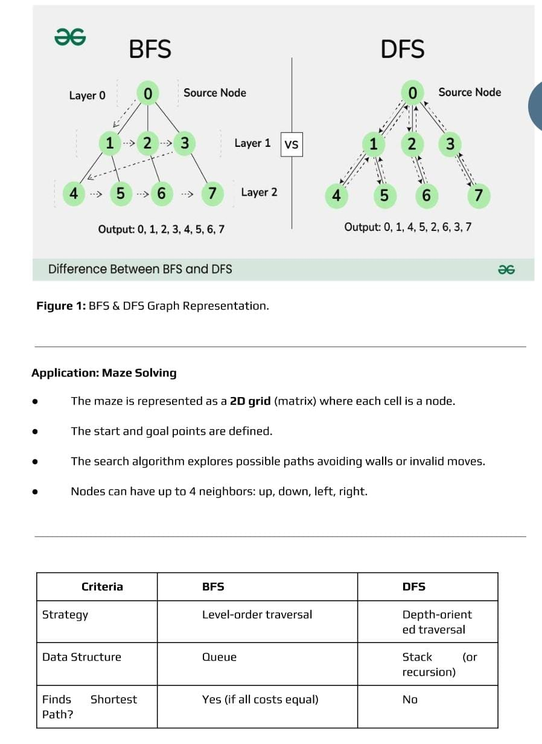

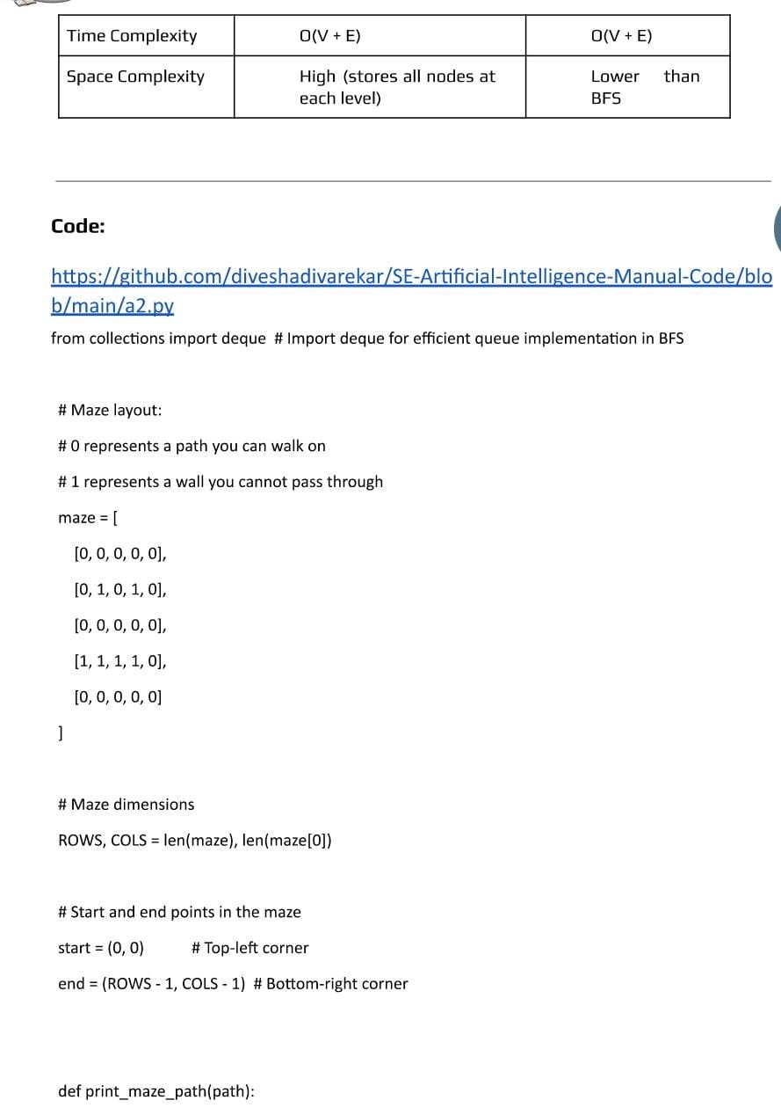
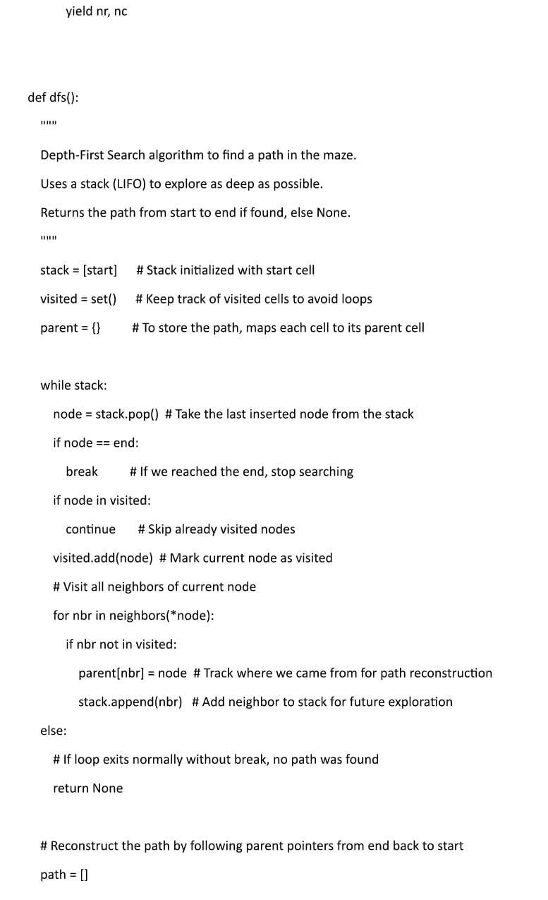
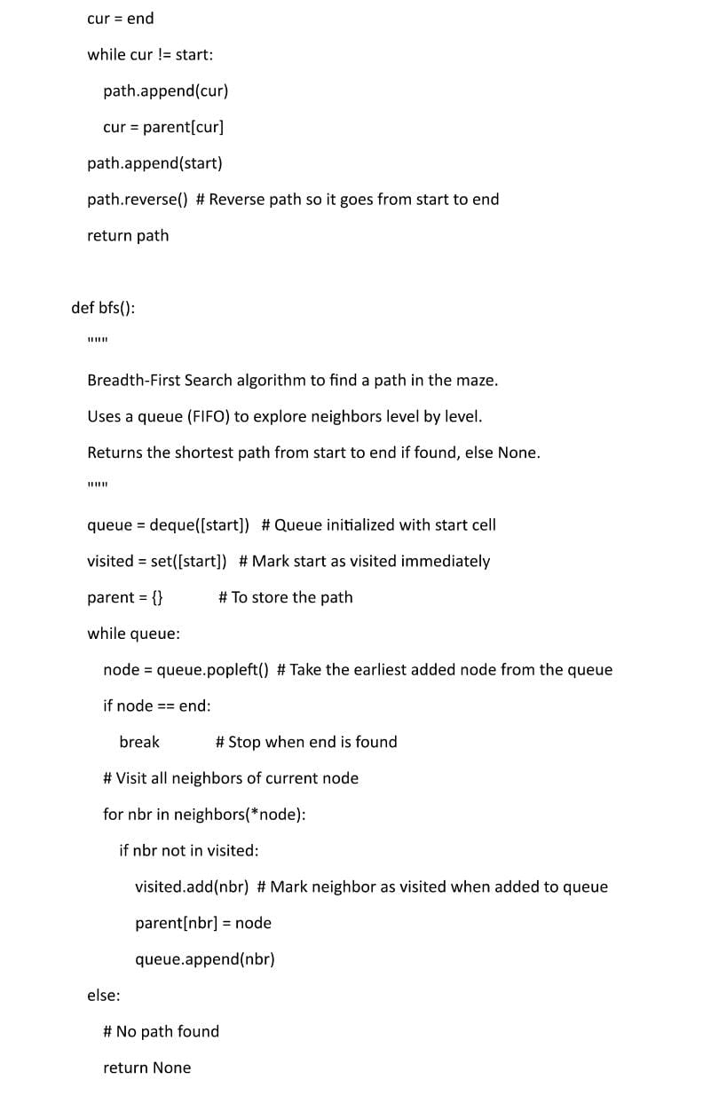
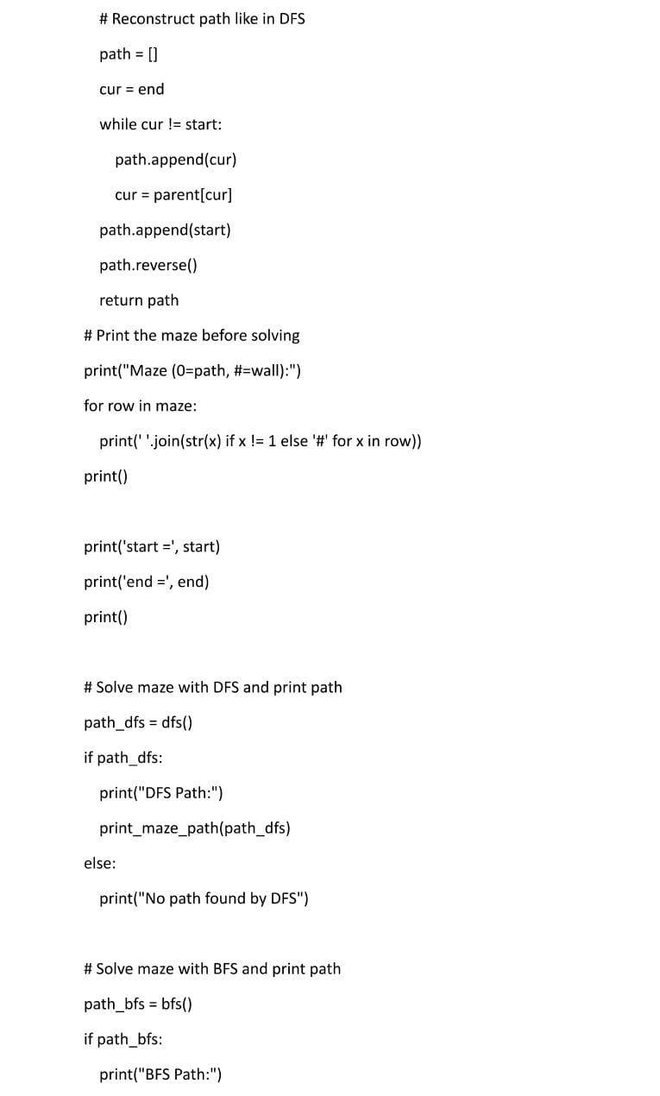
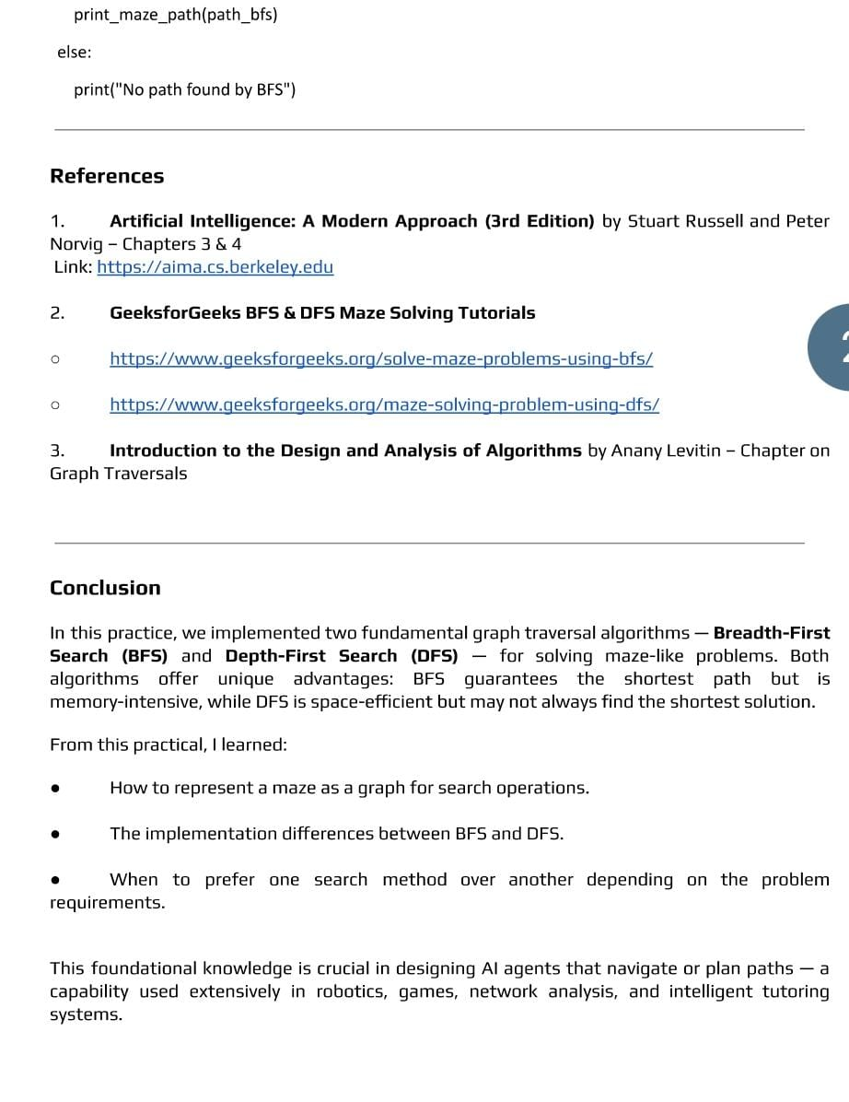

Input: graph = {
'A': ['B', 'D'],
'B': ['E', 'F'],
'D': ['G'],
'E': [],
'F': ['G'],
'G': []
}
Output:
Here is the Depth-First Search:
A B E F G D

Input: graph = {
'5': ['3', '7'],
'3': ['2', '4'],
'7': ['8'],
'2': [],
'4': ['8'],
'8': []
}
Output:
Here is the Breadth first search:
5 3 7 2 4 8
Conclusion:
Outcome:
Upon completion of this experiment, students will be able to:
ELO1: Use BFS and DFS correctly to explore a maze and find a path by treating the maze as a graph.
ELO2: Build a working maze solver program that shows how BFS finds the shortest path and how DFS explores deep paths first.
ELO3: Compare the performance of BFS and DFS algorithms.
Questions:
• What is Breadth First Search (BFS)?
• What is Depth First Search (DFS)?
• How does BFS differ from DFS in terms of search strategy?
• Which data structure is used in BFS and DFS?
• Give one application of BFS and one application of DFS.
4.3. Experiment No. 3
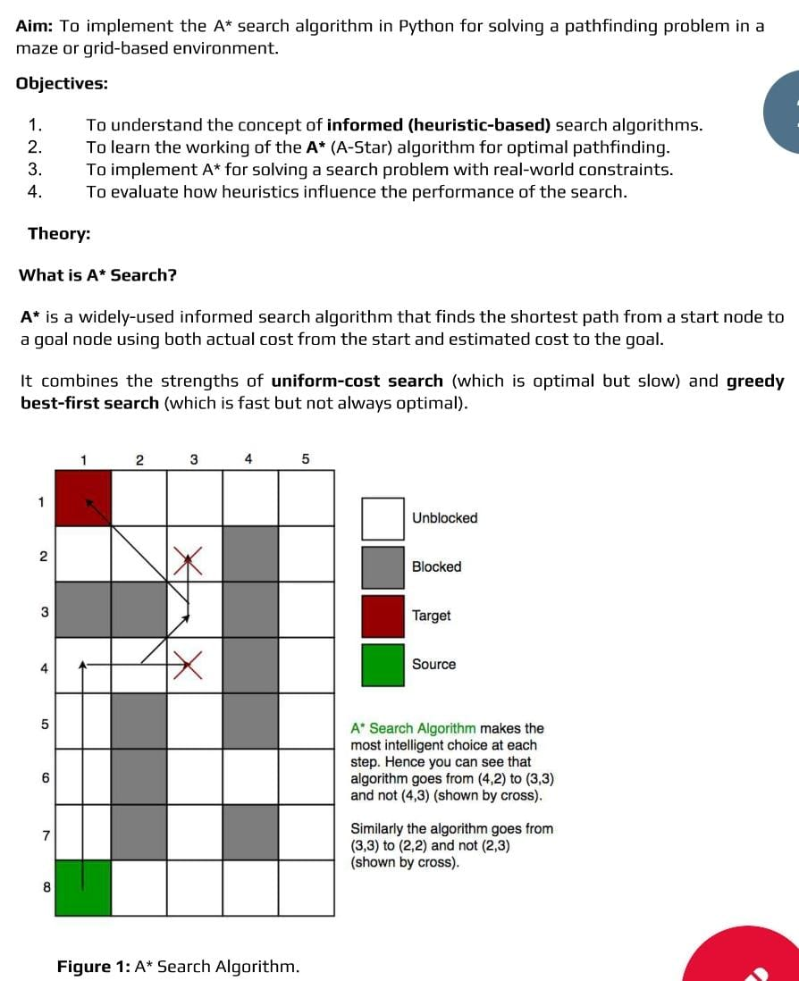

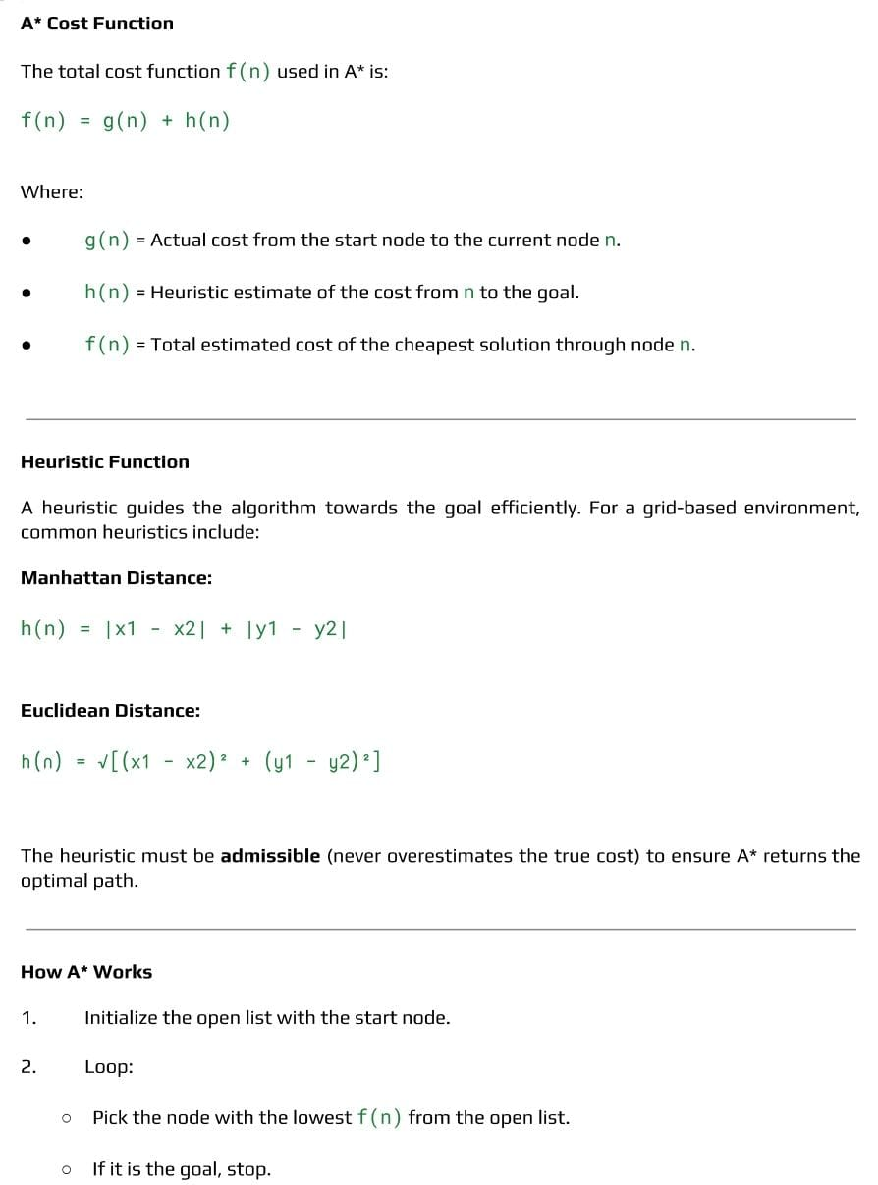
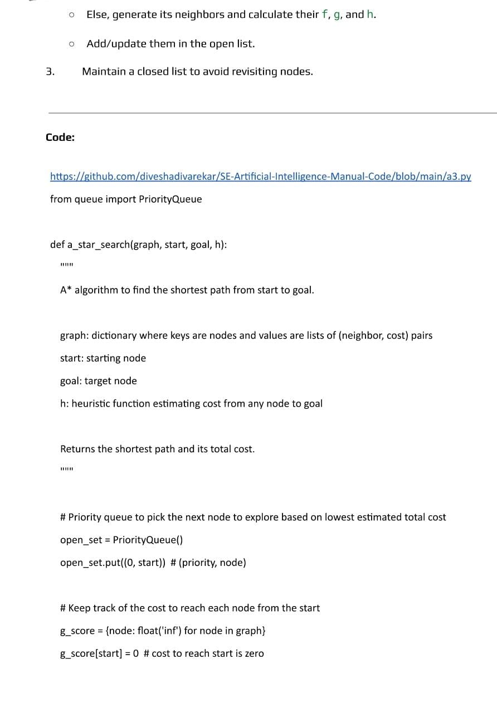
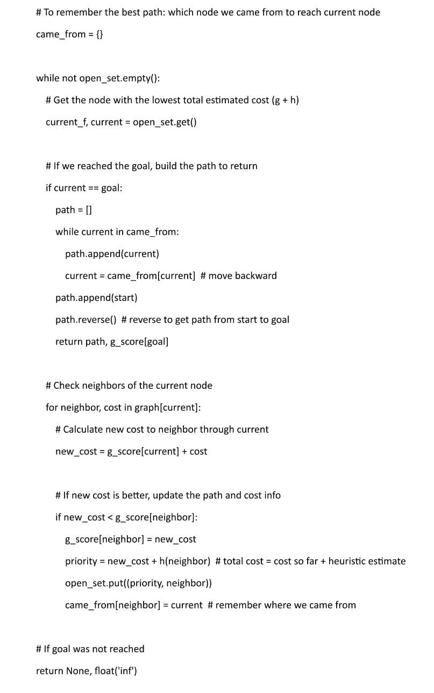
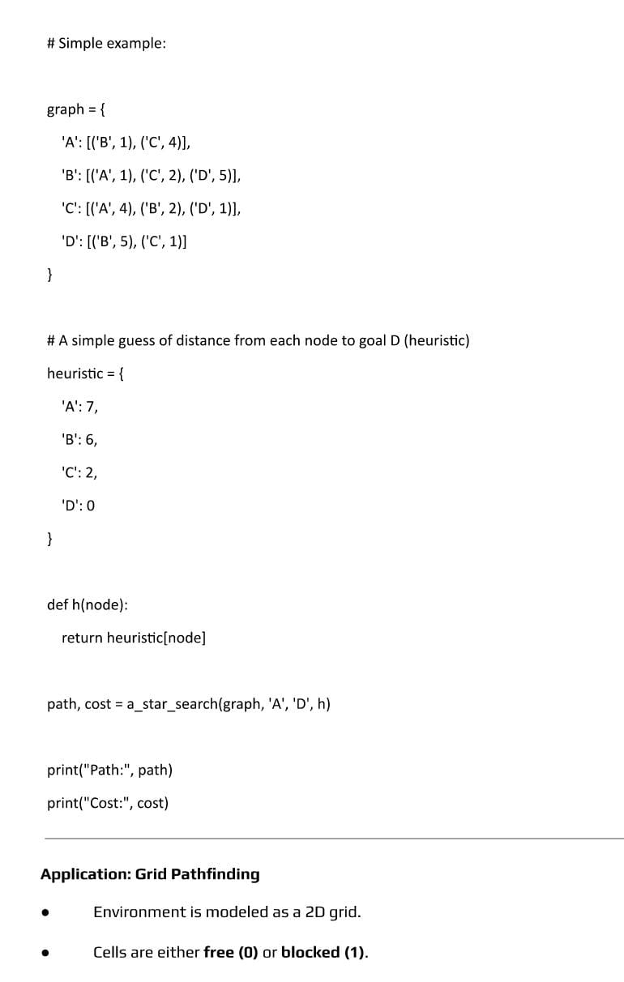

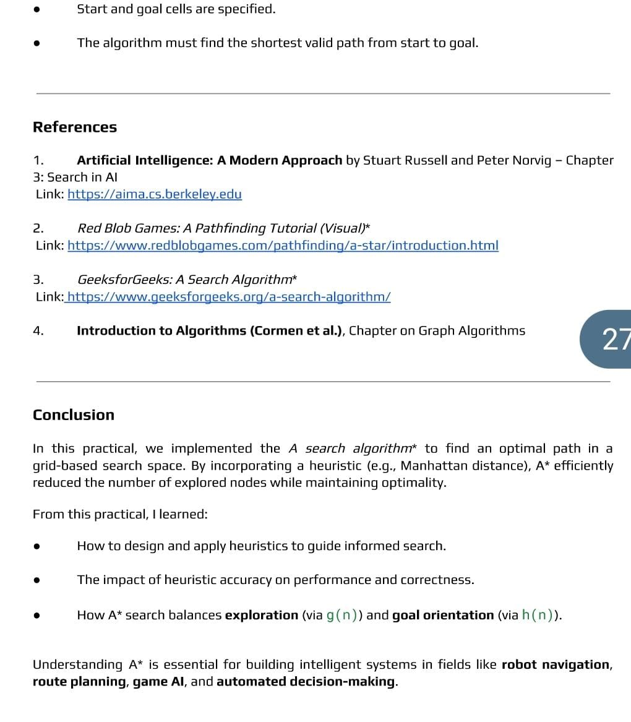

Input: graph = {
'A': {'B': 2, 'C': 5},
'B': {'A': 2, 'D': 2, 'E': 6},
'C': {'A': 5, 'F': 3},
'D': {'B': 2},
'E': {'B': 6, 'F': 1},
'F': {'C': 3, 'E': 1}
}
heuristic = {
'A': 7, 'B': 5, 'C': 3, 'D': 3, 'E': 1, 'F': 0
}
start = 'A'
goal = 'F'
Output: Path: ['A', 'C', 'F']
Conclusion:
Outcome:
Upon completion of this experiment, students will be able to:
ELO1: Use the A* algorithm to find the best (shortest) path in a graph by combining actual cost and heuristic estimates.
ELO2: Build a working program that applies A* correctly, showing how it selects the most promising nodes during the search.
ELO3: Test and compare A* with other search methods.
Questions:
• What is the A* (A star) algorithm?
• What is the role of the heuristic function in A*?
• What does the evaluation function f(n) represent in A*?
• How does A* differ from BFS or DFS?
• Give one application of the A* algorithm.

4.4. Experiment No. 4
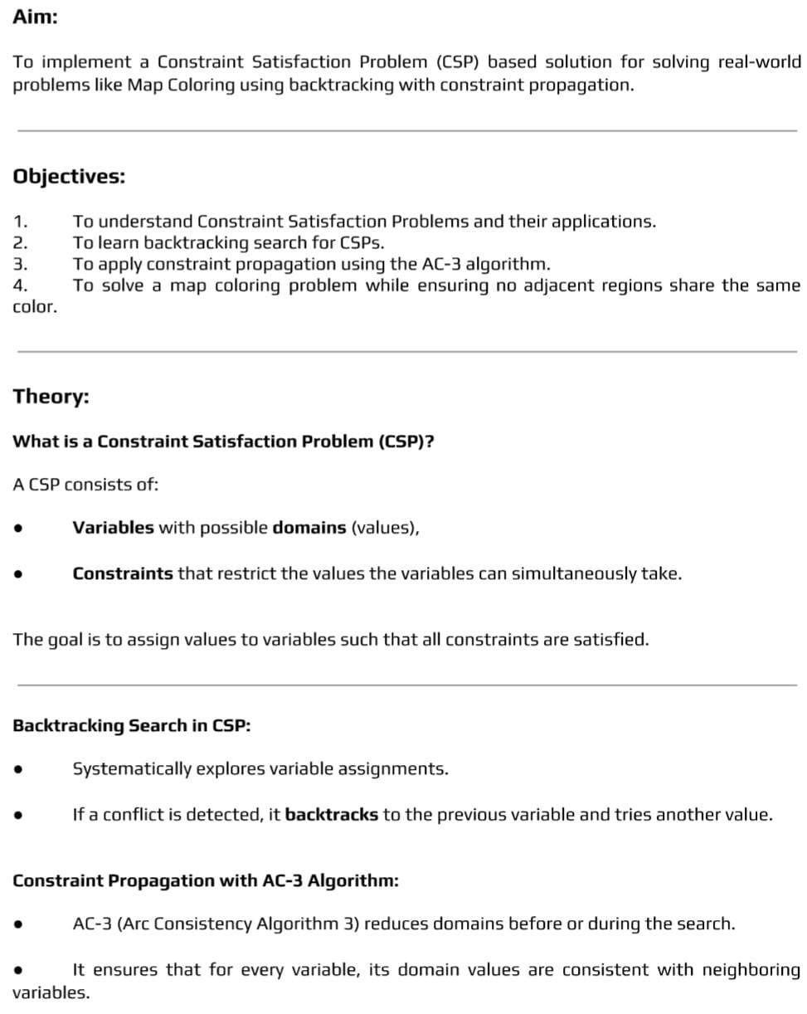
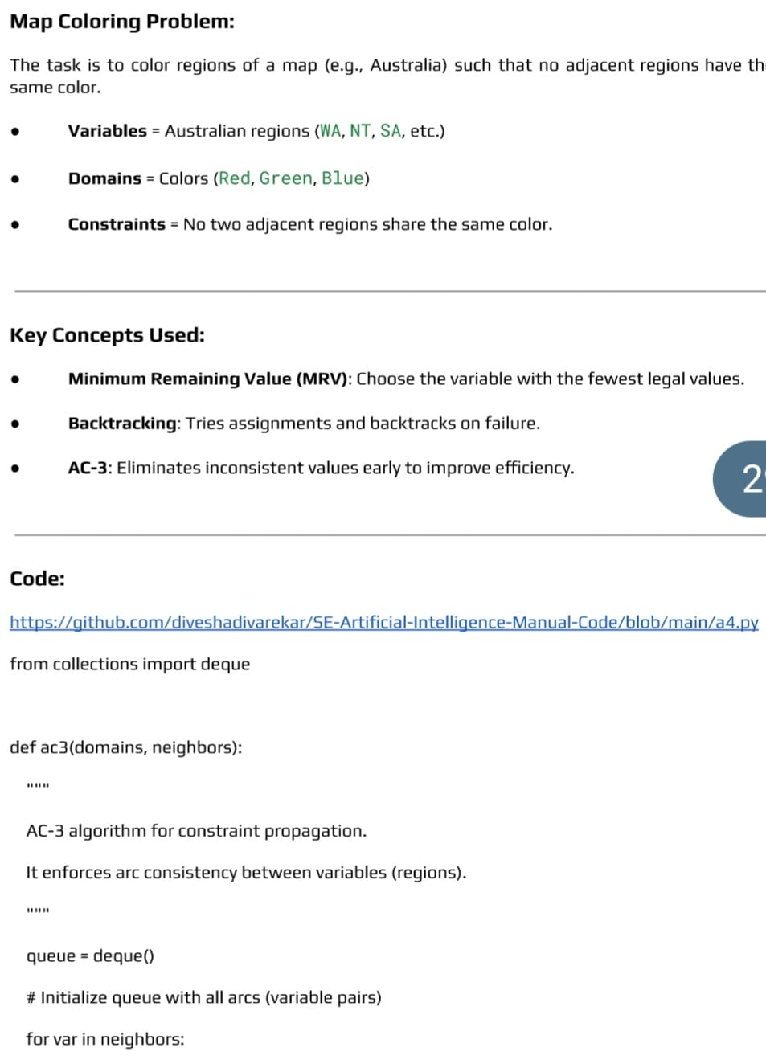

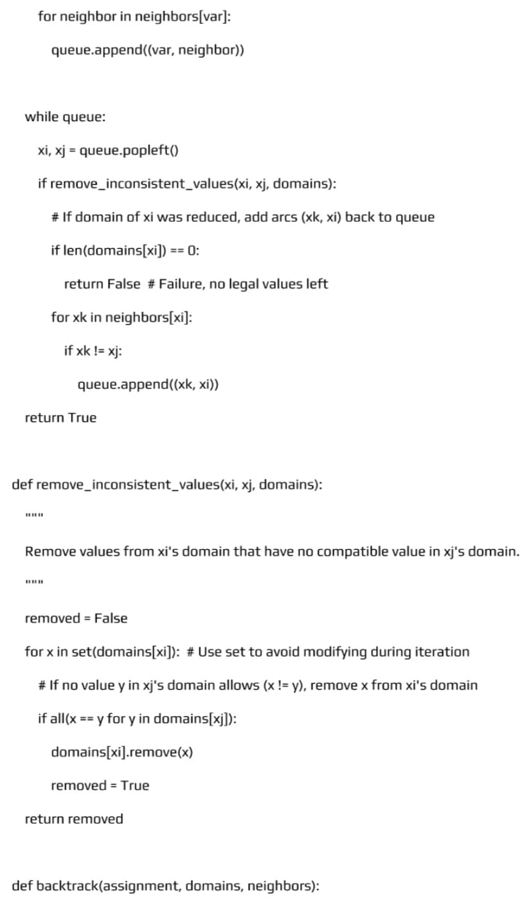
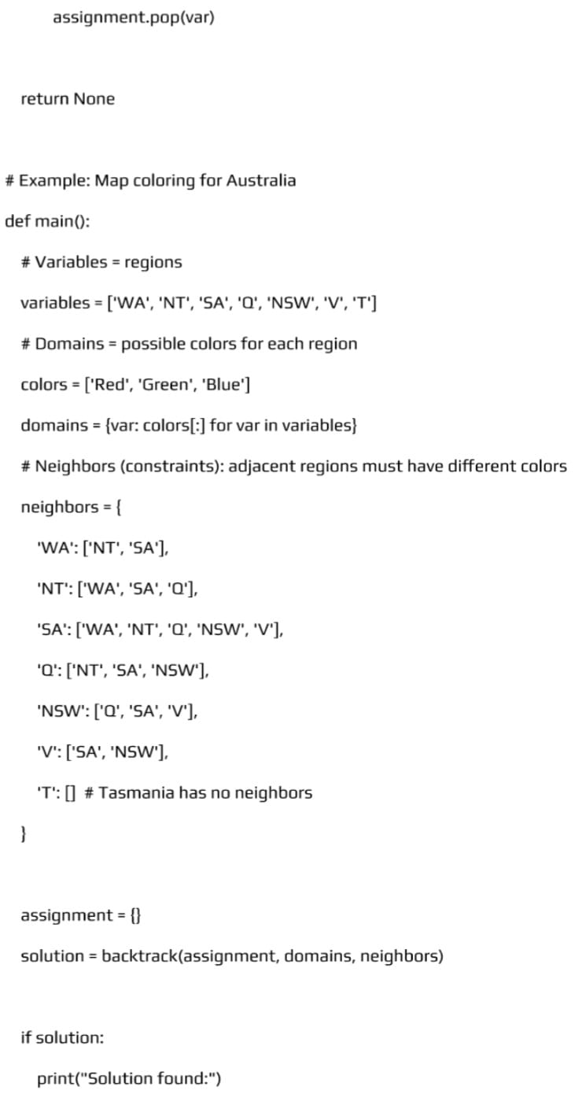
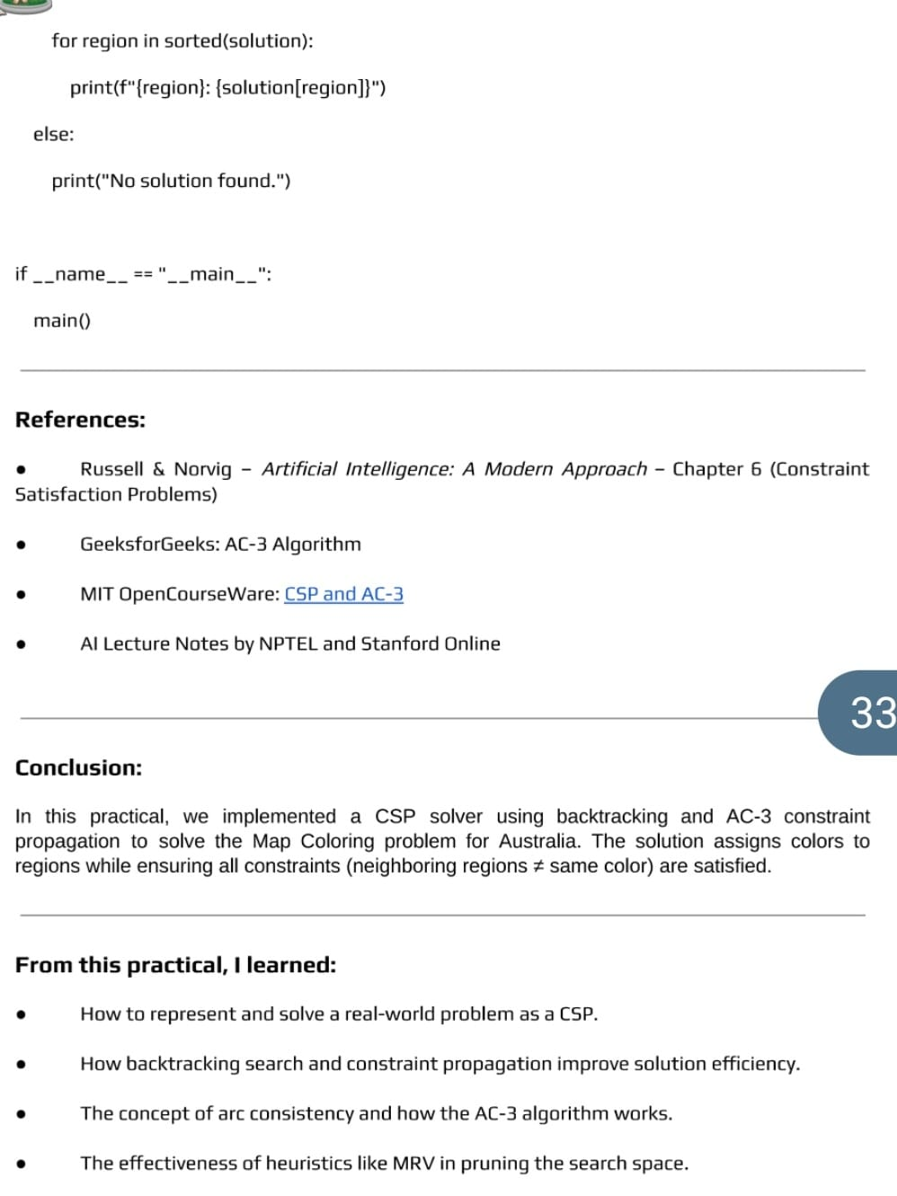
Input: Input:
Variables: Regions {A, B, C}
Domains: {Red, Green, Blue} for each region
Constraints:
A ≠ B
B ≠ C
A ≠ C
Output:
A = Red
B = Green
C = Blue
Conclusion:
Outcome:
Upon completion of this experiment, students will be able to:
ELO1: Create a CSP model by defining variables, domains, and constraints for problems like Sudoku, Map Coloring, or Timetable Scheduling.
ELO2: Build a working CSP solver that uses backtracking along with techniques like forward checking or arc consistency to reduce unnecessary searches.
ELO3: Test and improve the CSP solution by checking how efficiently it solves problems, reducing conflicts, and optimizing the search using better heuristics.
Questions:
• What is a Constraint Satisfaction Problem (CSP)?
• What are the main components of a CSP?
• What is a constraint in a CSP?
• Give one real-world example of a CSP.
• Which algorithm is commonly used to solve CSPs?
4.5.Experiment No. 5
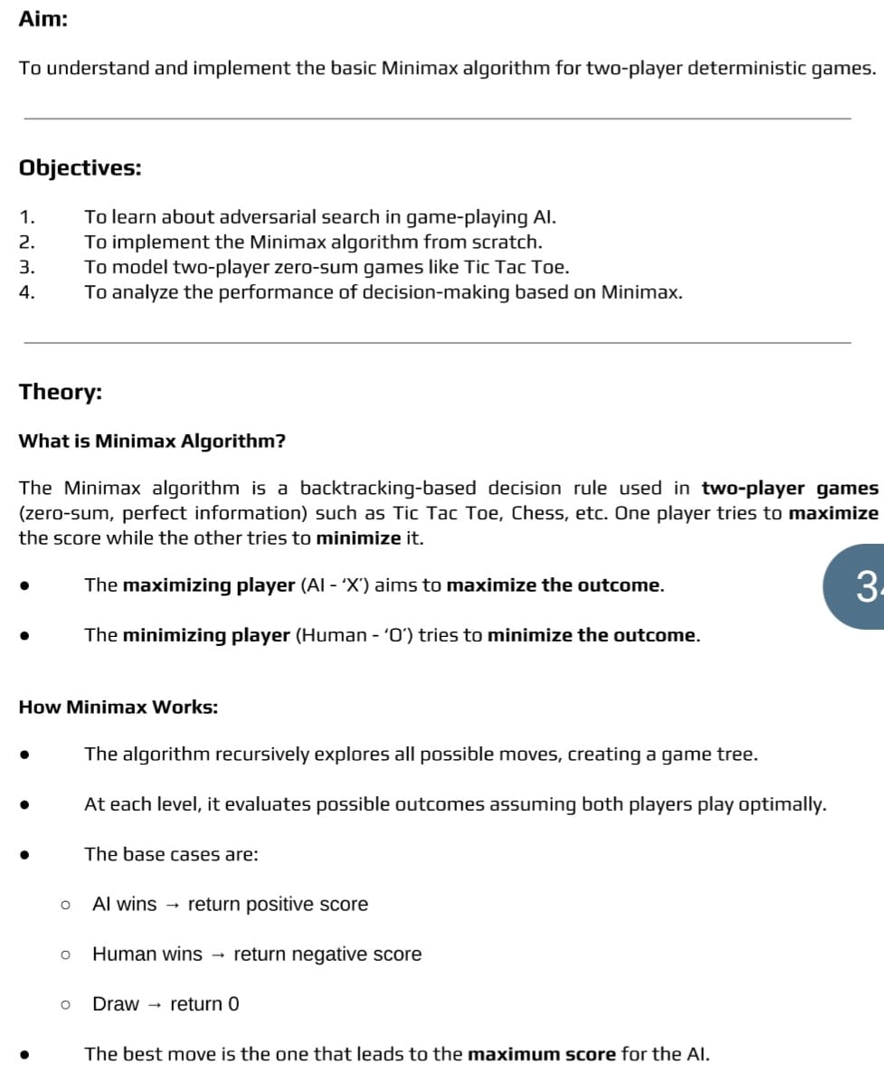

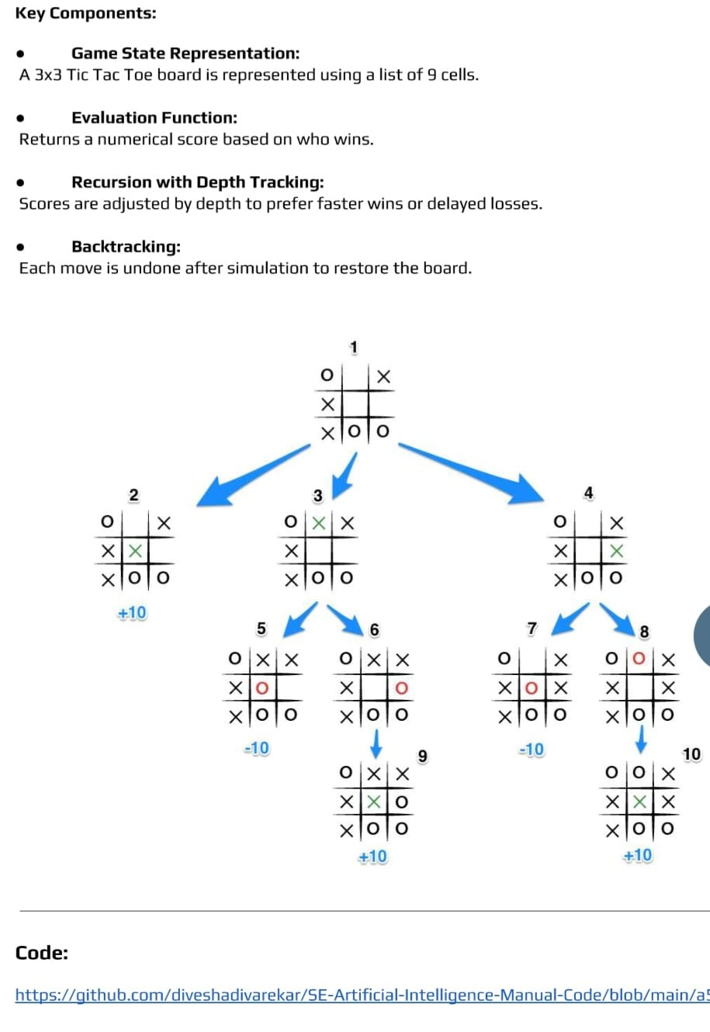
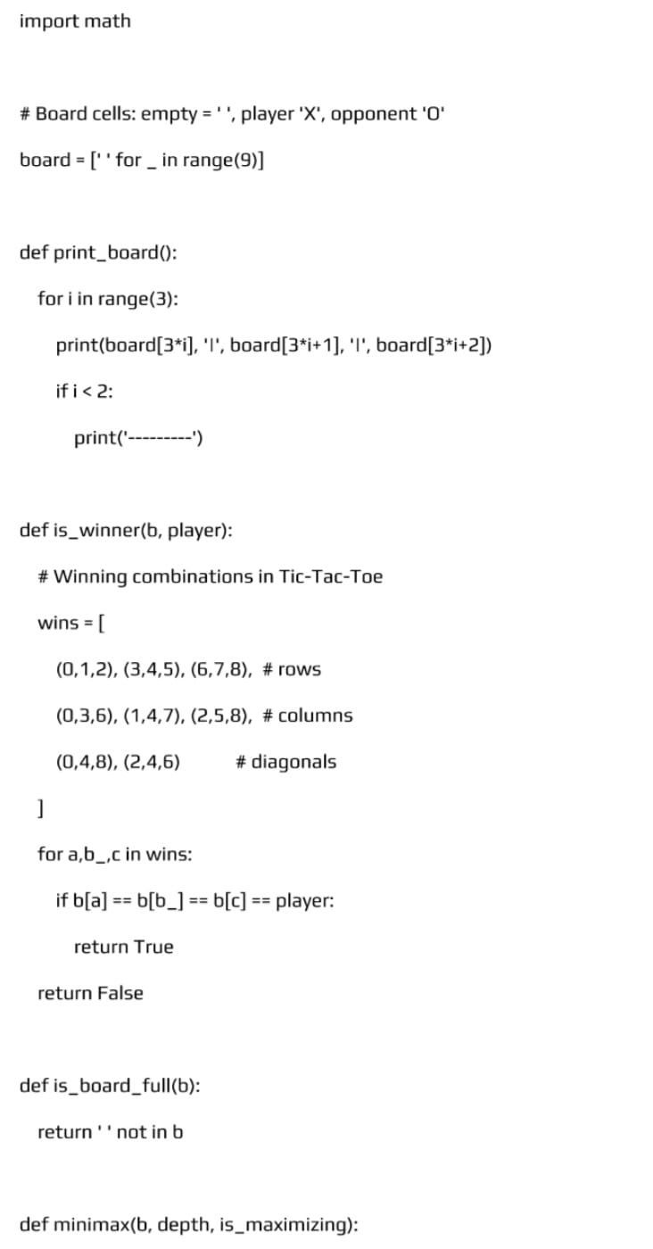
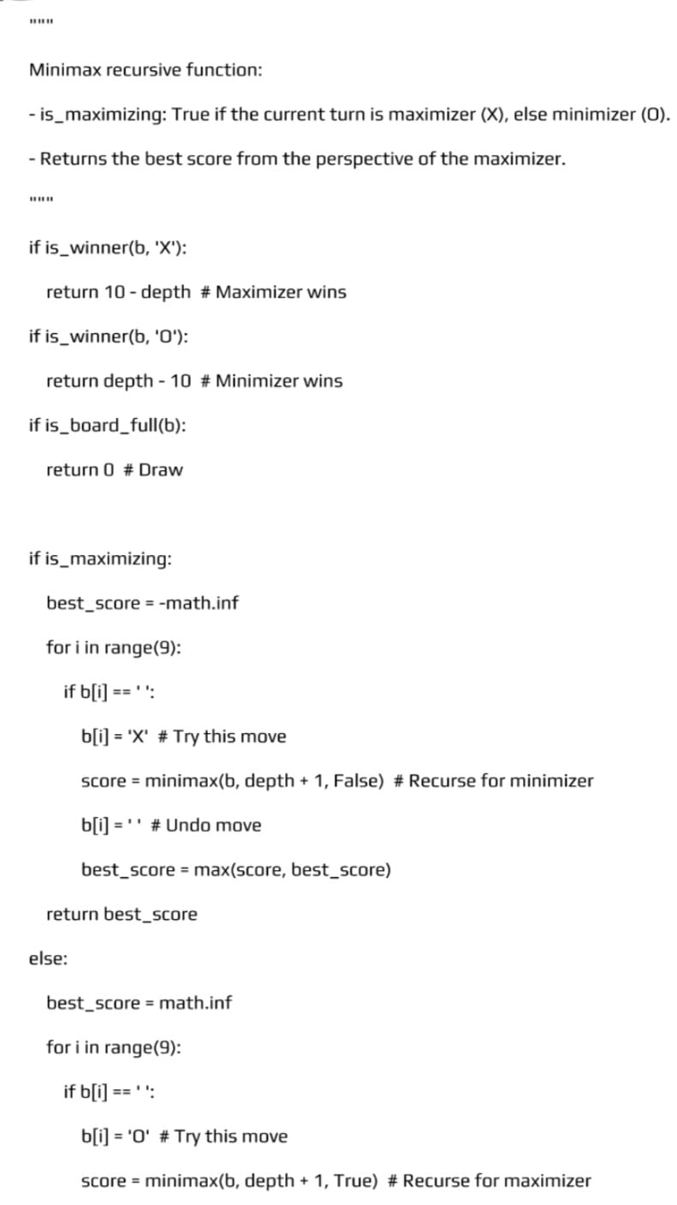
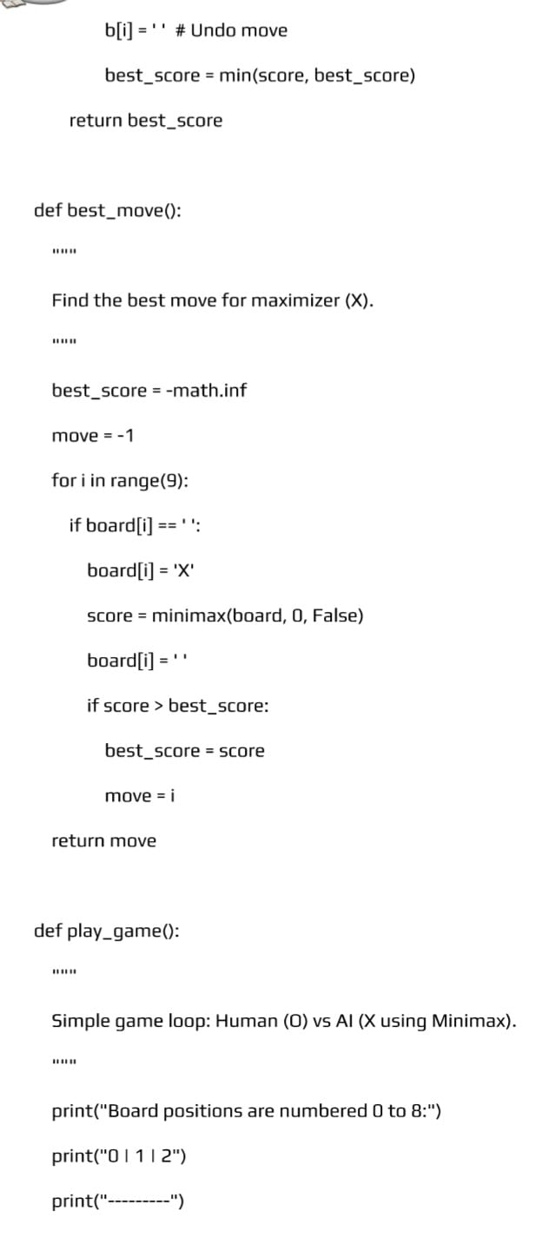
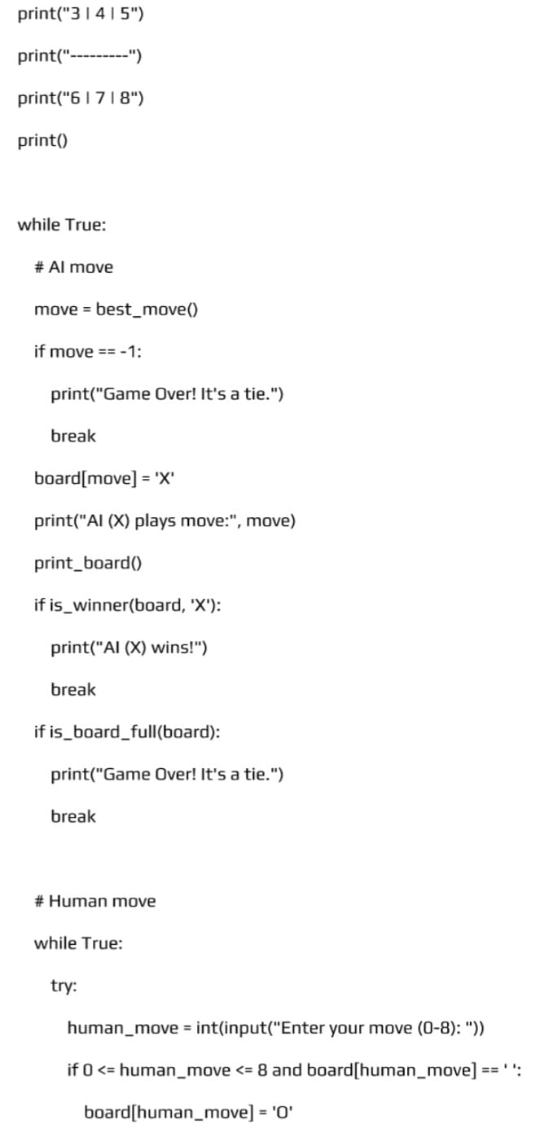
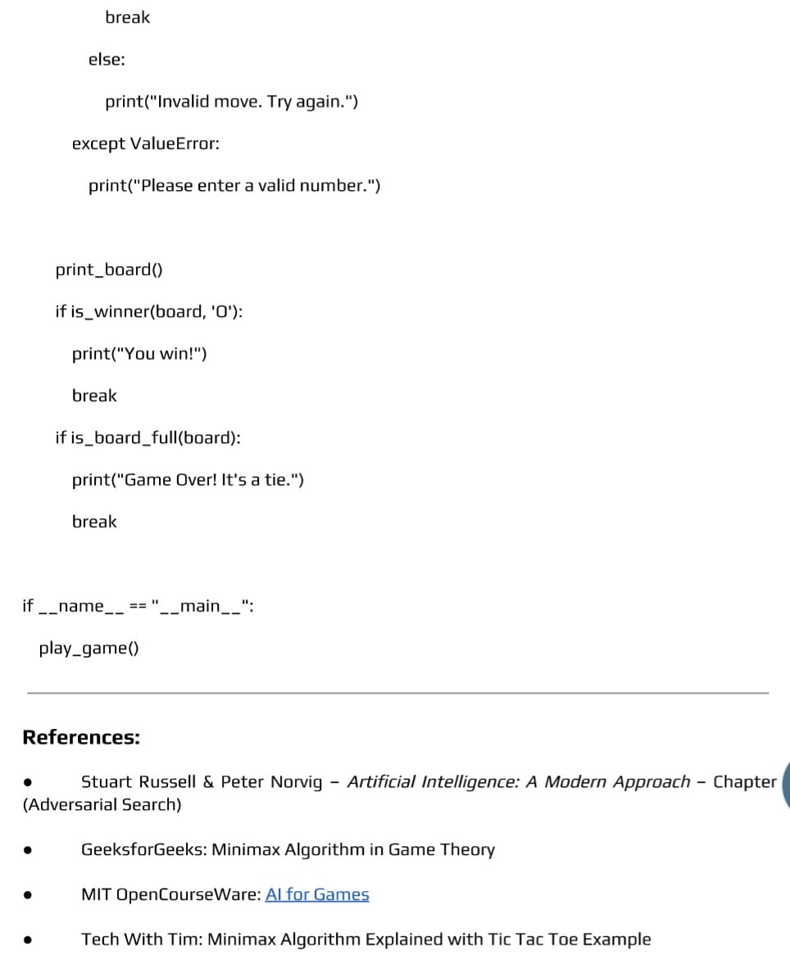
Input:
Game tree with terminal (leaf) values: [3, 5, 2, 9]
Player at root: MAX
Output:
Optimal value chosen by MAX: 3
Best move leads to the branch with value 3
Conclusion:
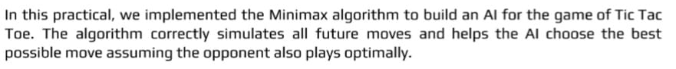
Outcome:
Upon completion of this experiment, students will be able to:
ELO1: Build a Minimax-based game agent that can correctly choose the best move by exploring game states in a two-player deterministic game.
ELO2: Create a working Minimax program that shows how the algorithm evaluates possible future moves and selects the most favorable outcome.
ELO3: Test the Minimax agent by playing against it, checking how it reacts to different situations, and improving its decision-making based on evaluation functions.
Questions:
- What is the Minimax algorithm?
- In which type of games is the Minimax algorithm used?
- What are MAX and MIN nodes in the Minimax algorithm?
- How does Minimax decide the best move?
- What is the main limitation of the Minimax algorithm?

4.6.Experiment No. 6
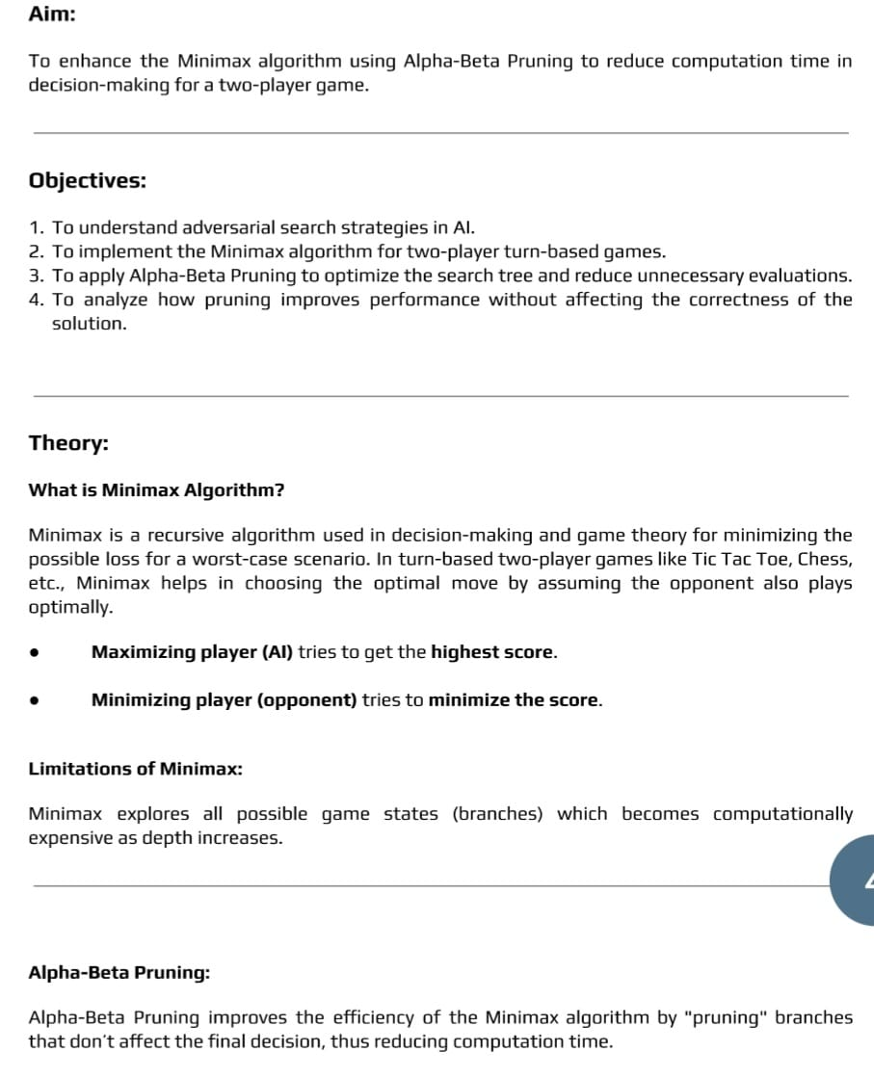

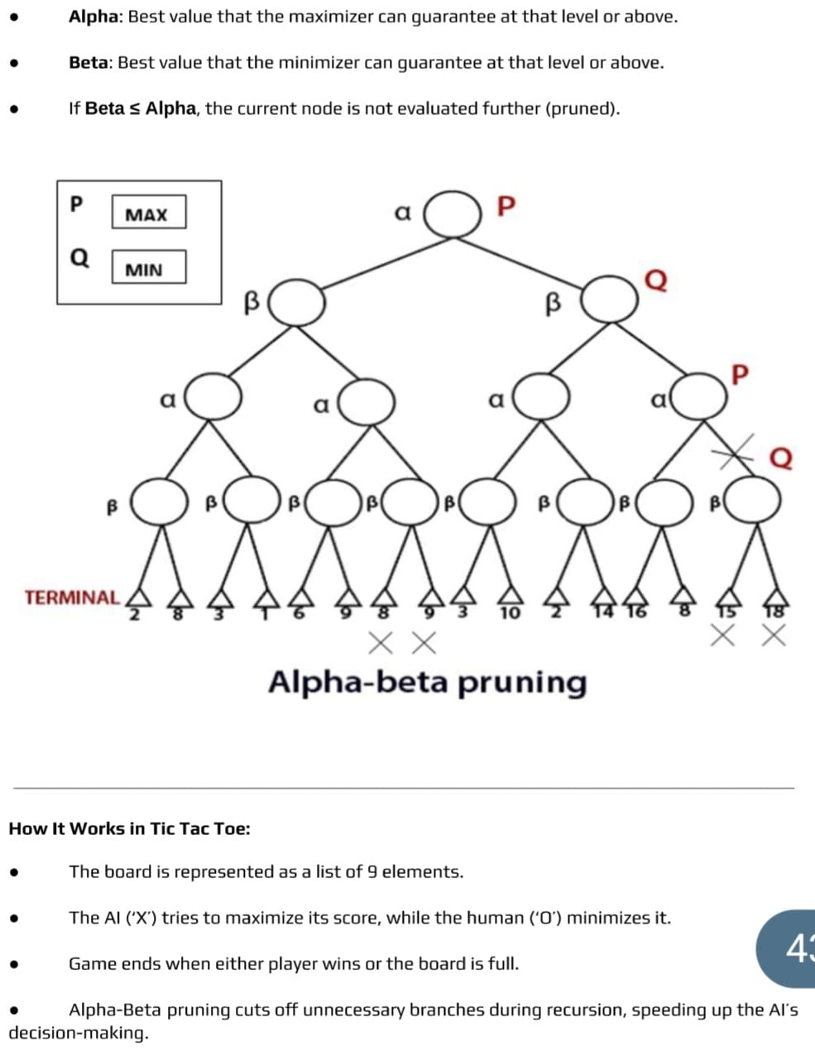

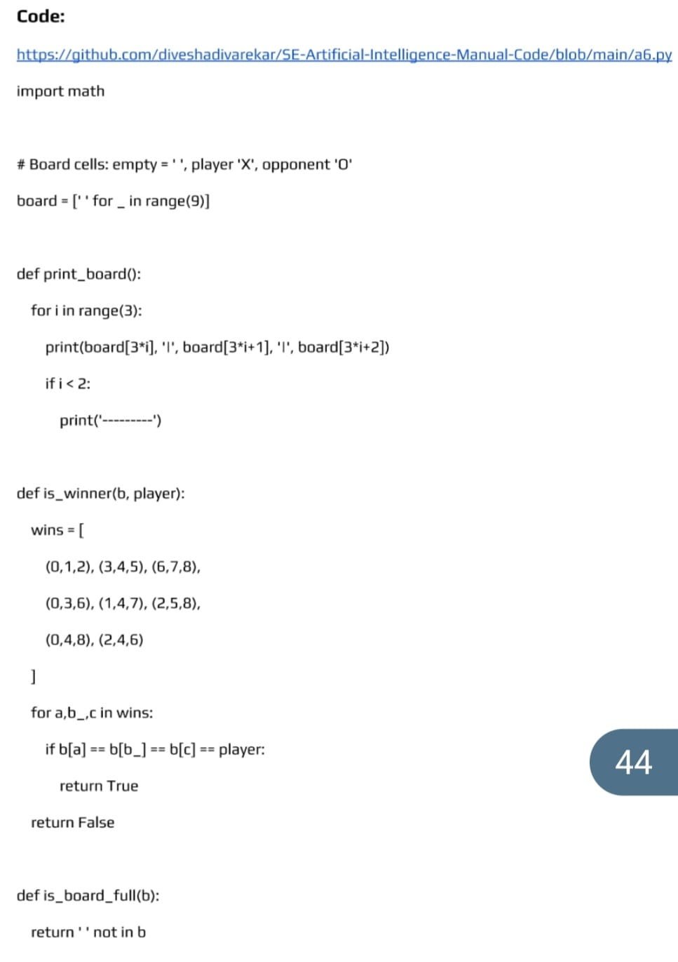

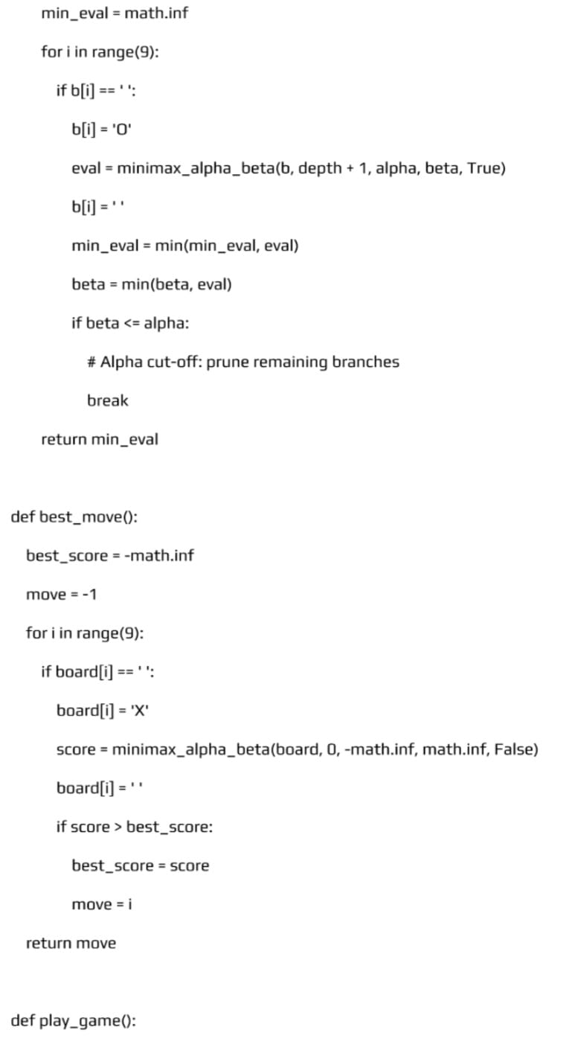
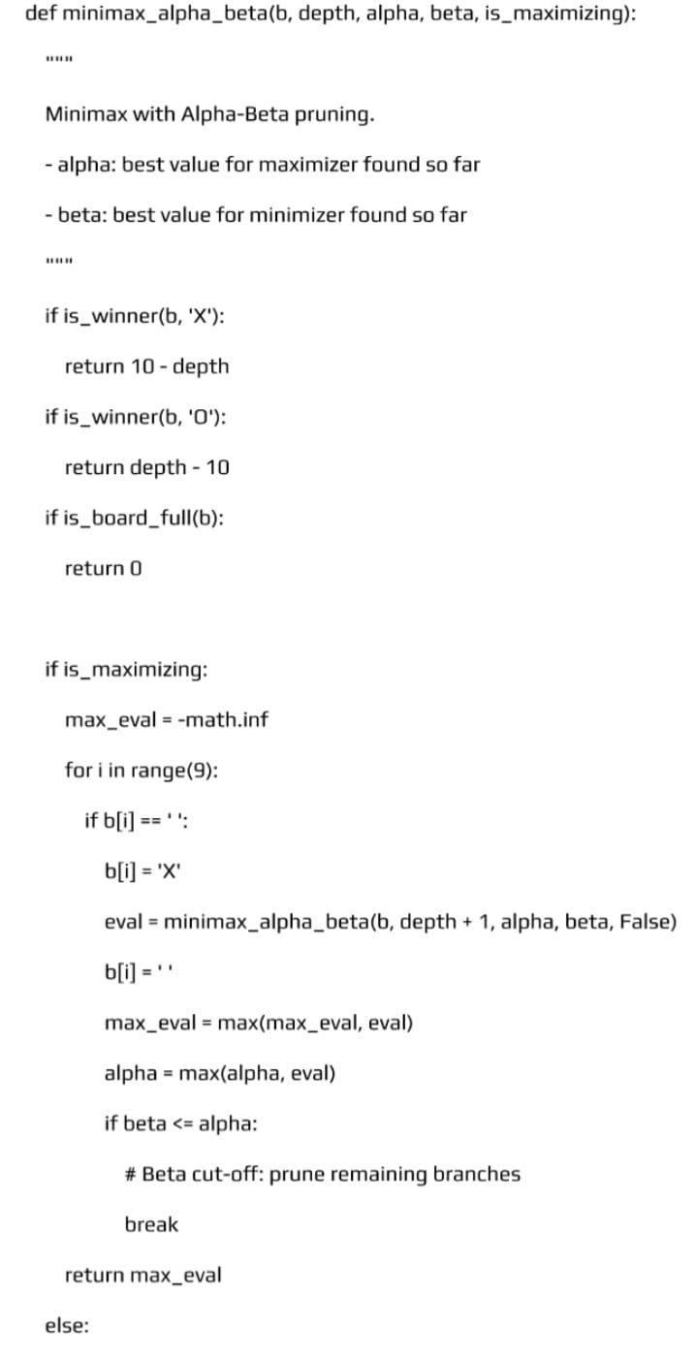
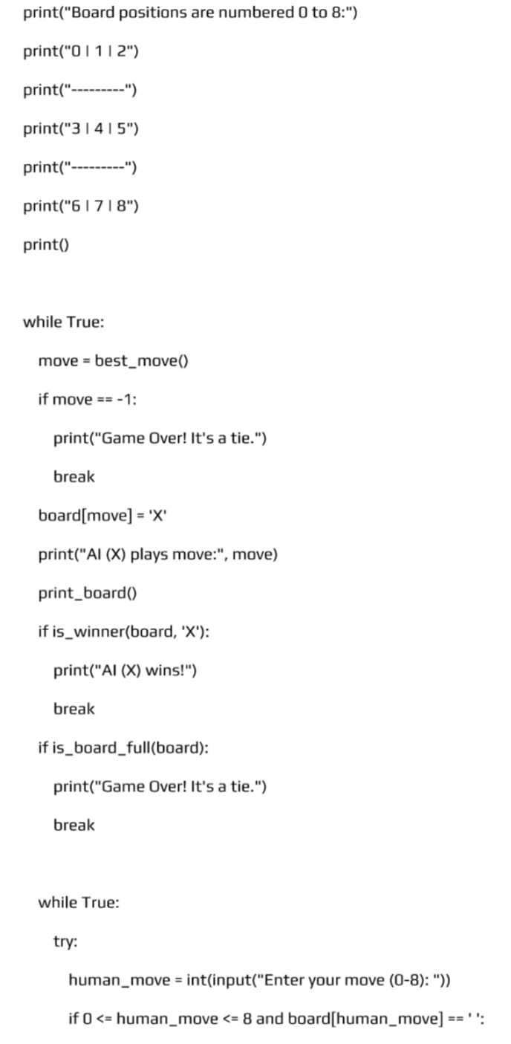
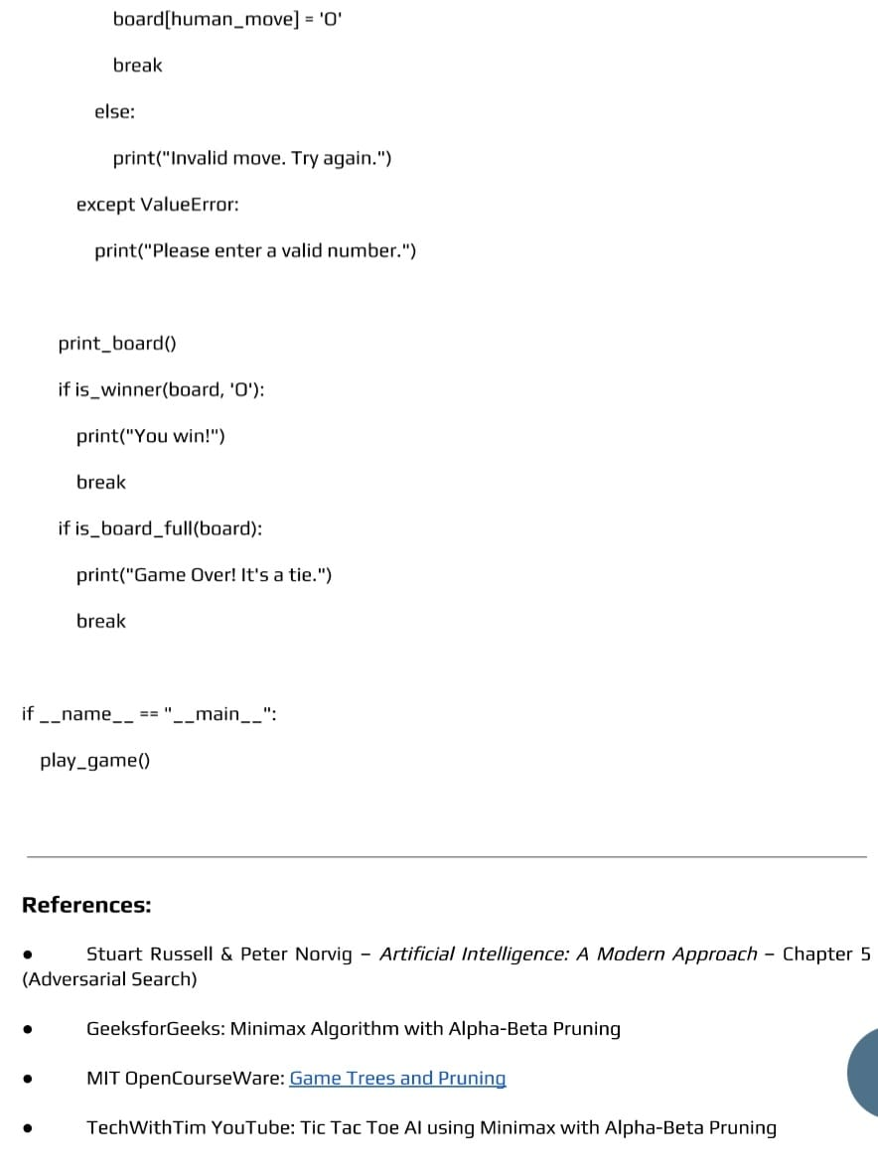
Input:
Game tree with terminal values: [3, 5, 2, 9]
Player at root: MAX
Alpha = −∞, Beta = +∞
Output:
Optimal value chosen by MAX: 3
Pruned node(s): Value 9 (not evaluated)
Conclusion:
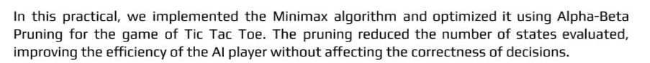
Outcome: Upon completion of this experiment, students will be able to:
ELO1: Implement Minimax with Alpha-Beta pruning so the program makes the same optimal move as plain Minimax but checks far fewer positions.
ELO2: Build a playable agent that uses Alpha-Beta pruning and demonstrates correct decision-making in two-player deterministic games (e.g., tic-tac-toe, connect-4, or a simple chess endgame).
ELO3: Measure and compare performance (nodes explored, time, memory) between Minimax and Alpha-Beta; show how move ordering improves pruning and explain why pruning saves computation.
Questions:
• What is Alpha–Beta Pruning?
• Why is Alpha–Beta Pruning used in Minimax?
• What do alpha (α) and beta (β) represent?
• Does Alpha–Beta Pruning change the final result of Minimax?
• In which type of games is Alpha–Beta Pruning applied?
4.7. Experiment No.7
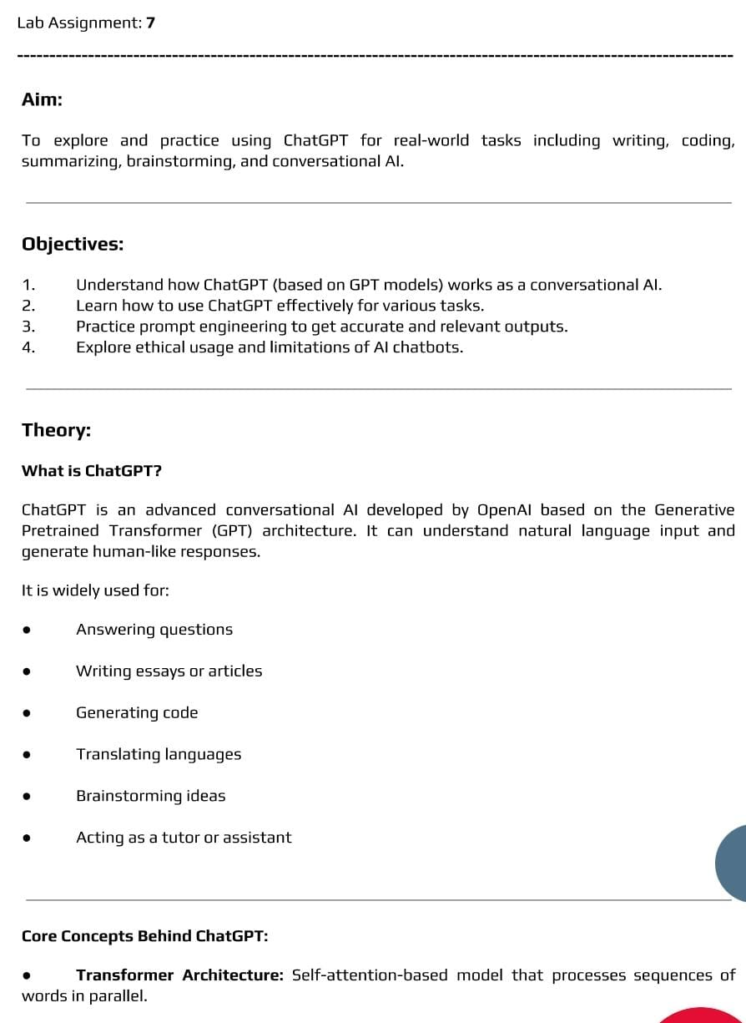

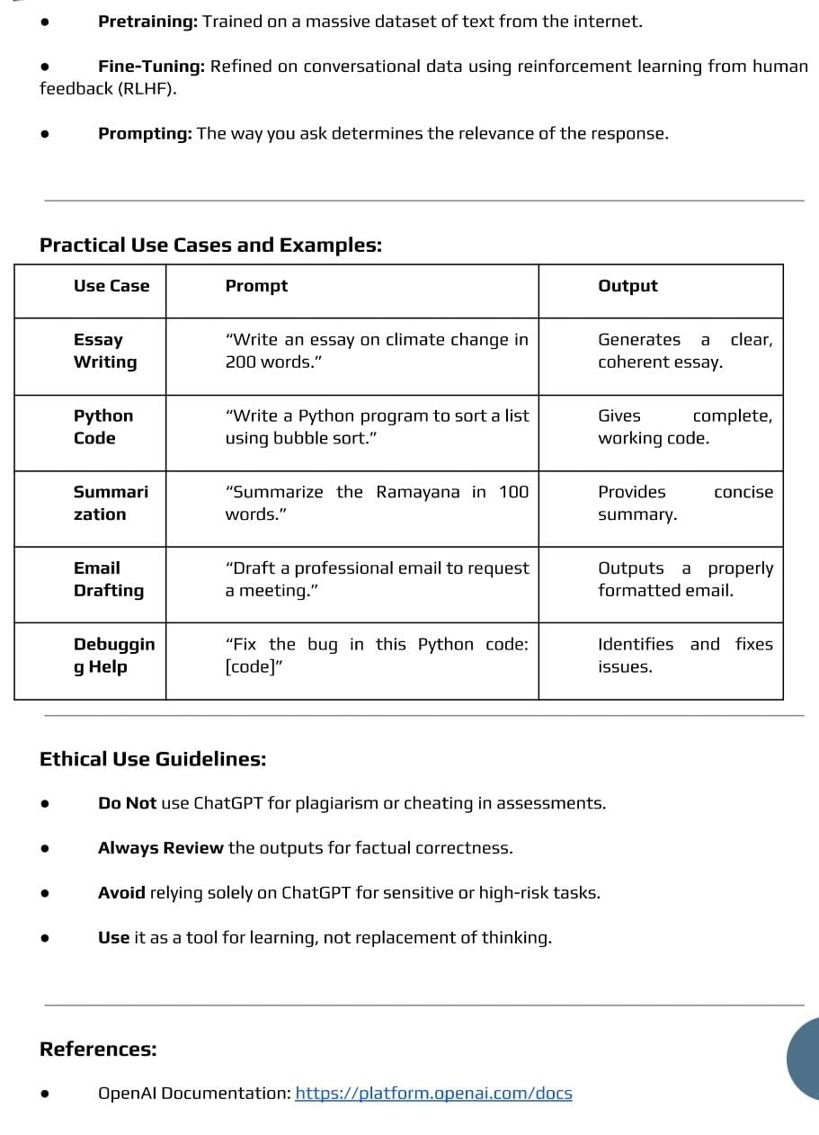

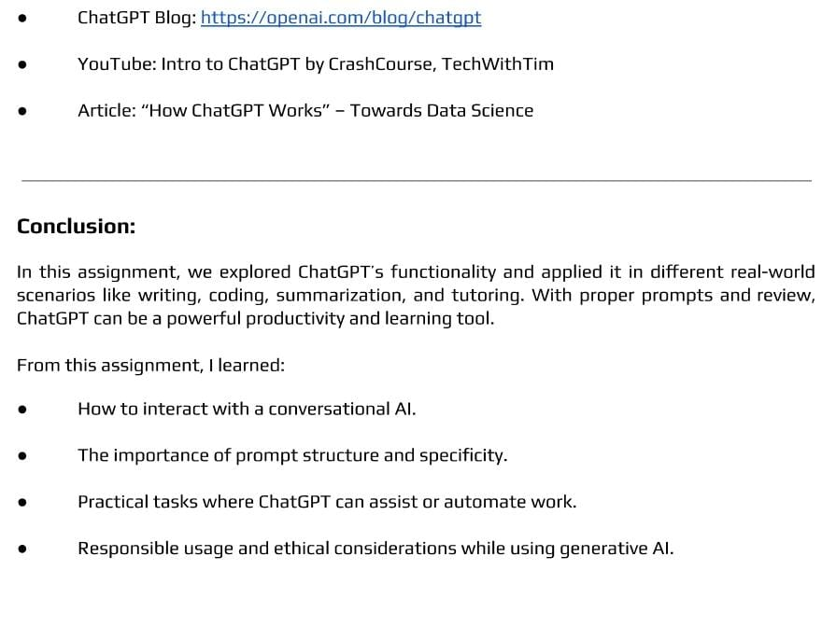
Input:
User: “Explain Breadth First Search in simple terms.”
Output:
ChatGPT: “Breadth First Search (BFS) is a search algorithm that explores all neighboring nodes first before moving to the next level. It uses a queue and is commonly used to find the shortest path in unweighted graphs.”
Another Simple Example
Input:
User: “Convert the sentence ‘AI is powerful’ into passive voice.”
Output:
ChatGPT: “The sentence ‘AI is powerful’ is already in passive form.”
If you want, I can give very short, viva-style, or exam record format examples.
Conclusion:
Outcome:
Upon completion of this experiment, students will be able to:
ELO1: Use ChatGPT effectively to get clear, accurate, and helpful answers for different types of tasks and questions.
ELO2: Create well-designed prompts to improve the quality of ChatGPT responses and understand how prompt wording affects output.
ELO3: Evaluate ChatGPT answers for correctness and usefulness, and refine prompts to get better results for academic, creative, or practical tasks.
Questions:
• What is ChatGPT?
• Who developed ChatGPT?
• What type of AI model is ChatGPT?
• What are two common uses of ChatGPT?
• Can ChatGPT think or make decisions on its own like a human?

4.8. Experiment No. 8
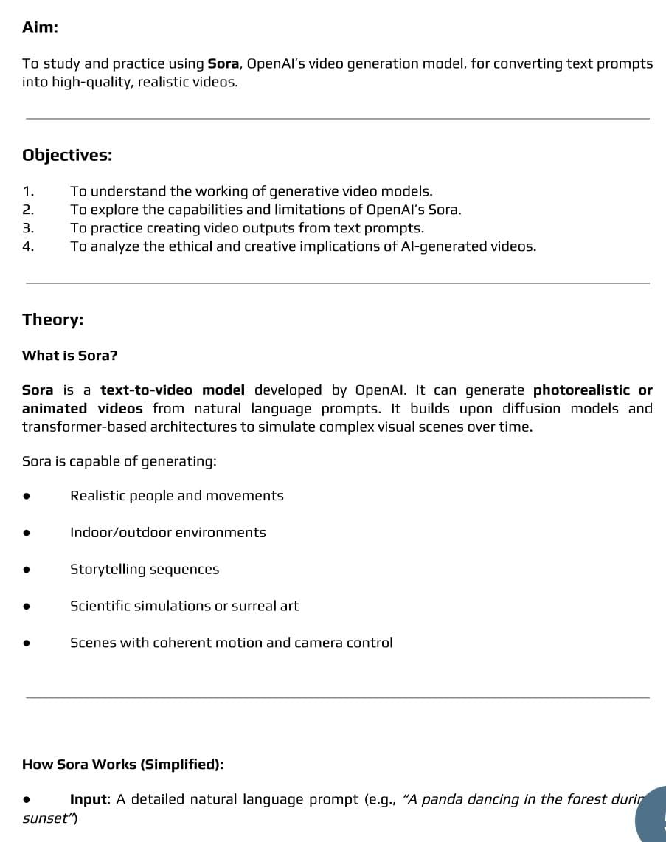

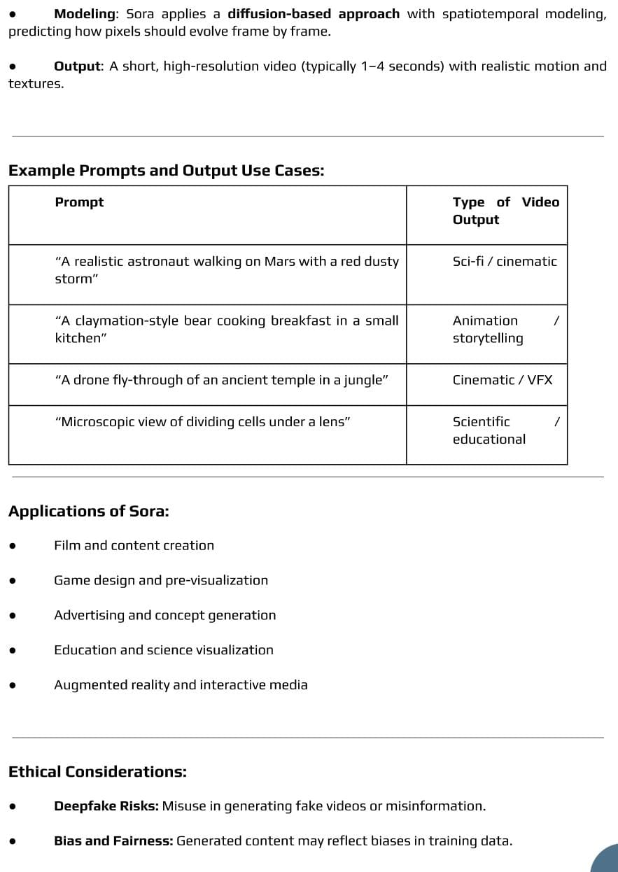

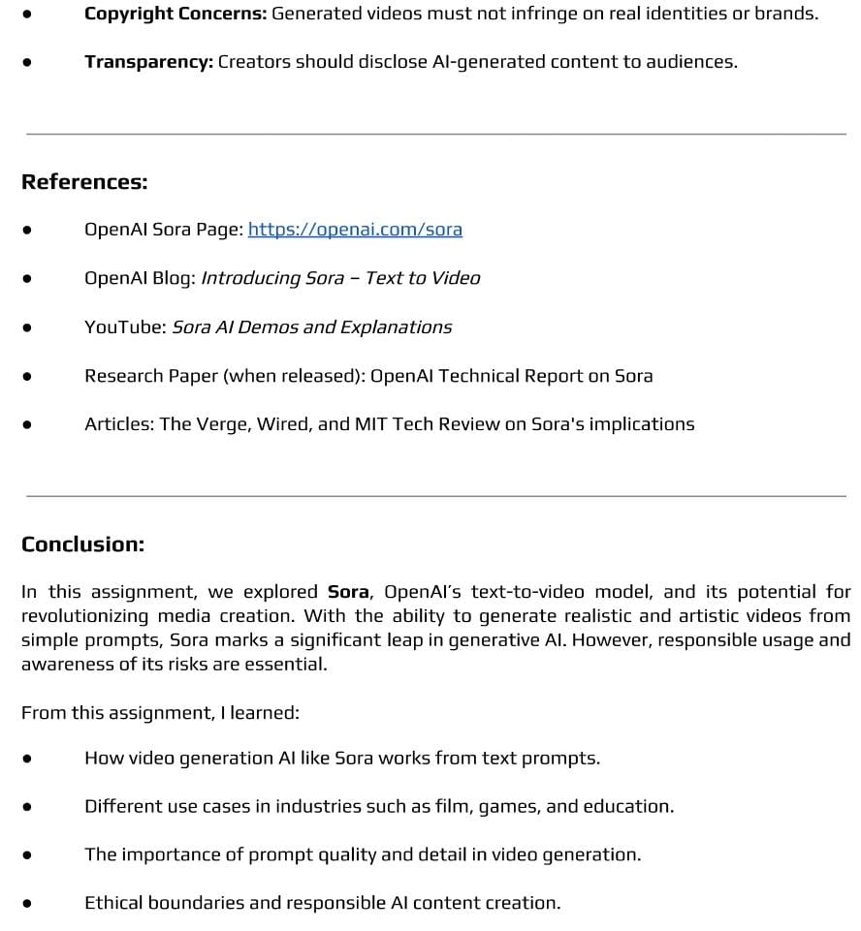
Input:
User: “Create a short video of a cat playing with a ball in a garden.”
Output:
Sora: “A short, realistic video showing a cat running and playing with a ball on green grass in a garden.”
Conclusion:
Outcome:
Upon completion of this experiment, students will be able to:
ELO1: Create effective prompts that guide SORA to generate meaningful and visually accurate videos.
ELO2: Use different prompt styles, scene descriptions, and settings to understand how SORA converts text into videos.
ELO3: Evaluate the generated videos for quality, realism, and accuracy, and improve the prompts to get better and more consistent results.
Questions:
• What is SORA?
• What type of content can SORA generate?
• Who developed SORA?
• What input does SORA take to generate videos?
• How is SORA different from text-based AI models like ChatGPT?

4.9. Experiment No. 9
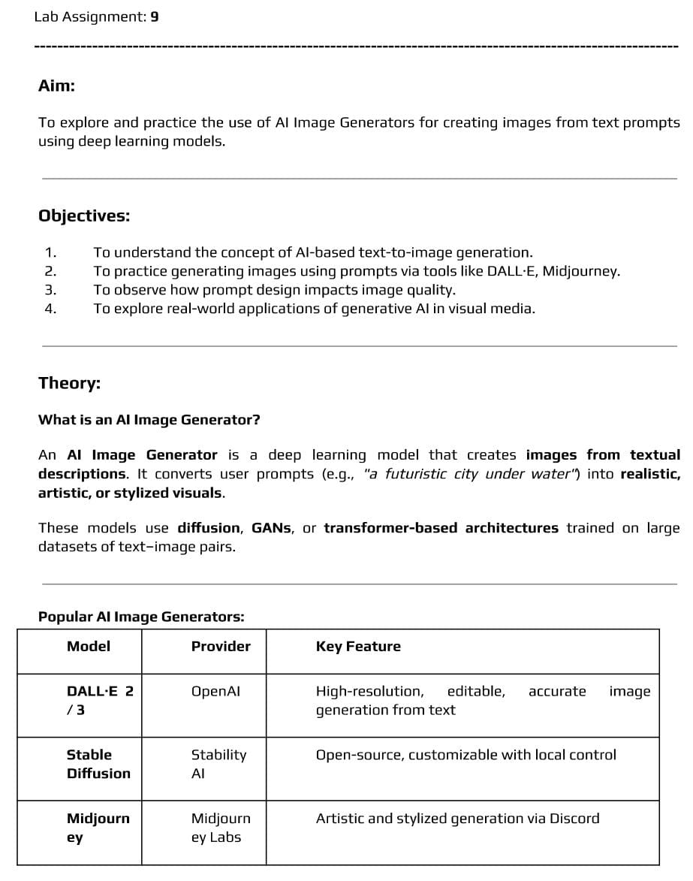
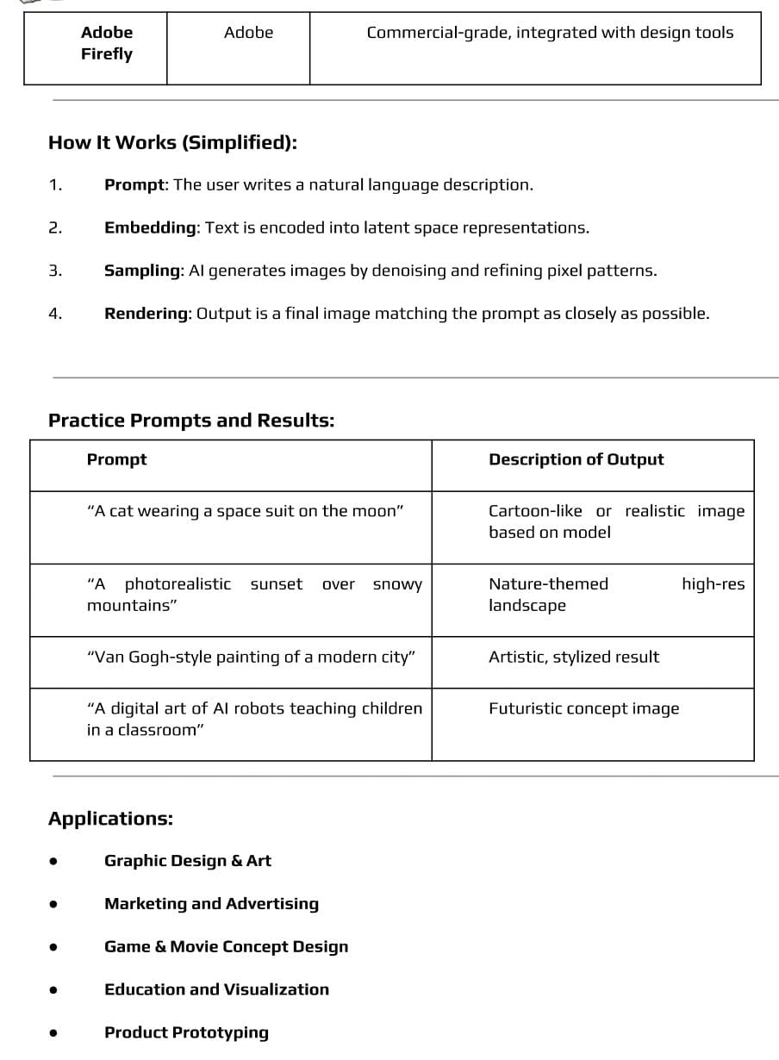
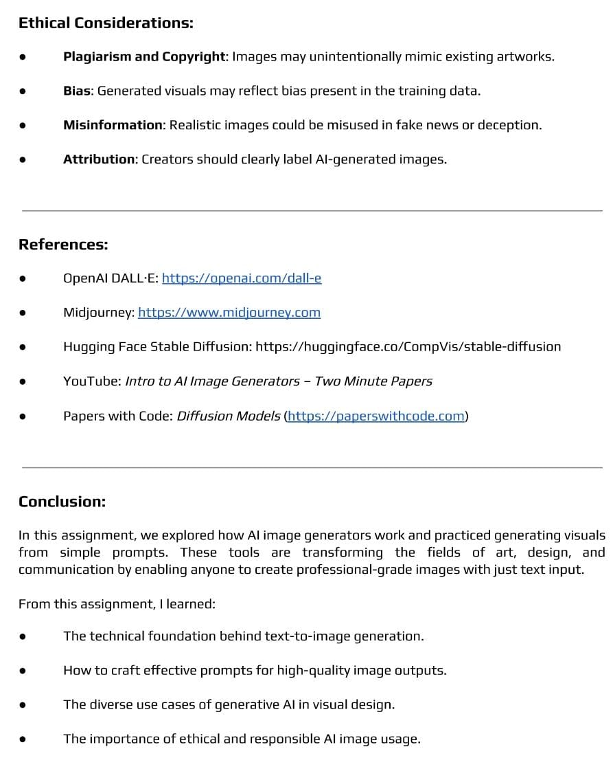
Input:
Prompt: "A cute cartoon dog wearing a wizard hat”
Output: An AI-generated cartoon-style image of a dog with big eyes, a small wizard hat, and a magical background.
Conclusion:

Outcome:
Upon completion of this experiment, students will be able to:
ELO1: Create clear prompts that help the AI image generator produce accurate and meaningful images based on user requirements.
ELO2: Use different prompt styles and settings to generate high-quality images and understand how changes in prompts affect the output.
ELO3: Evaluate the generated images for clarity, accuracy, and creativity, and improve the prompts to get better results.
Questions:
• What is an AI image generator?
• How does an AI image generator create images from text?
• Name one popular AI image generation tool.
• What is a prompt in AI image generation?
• Can AI image generators create realistic and abstract images?

4.10. Experiment No. 10
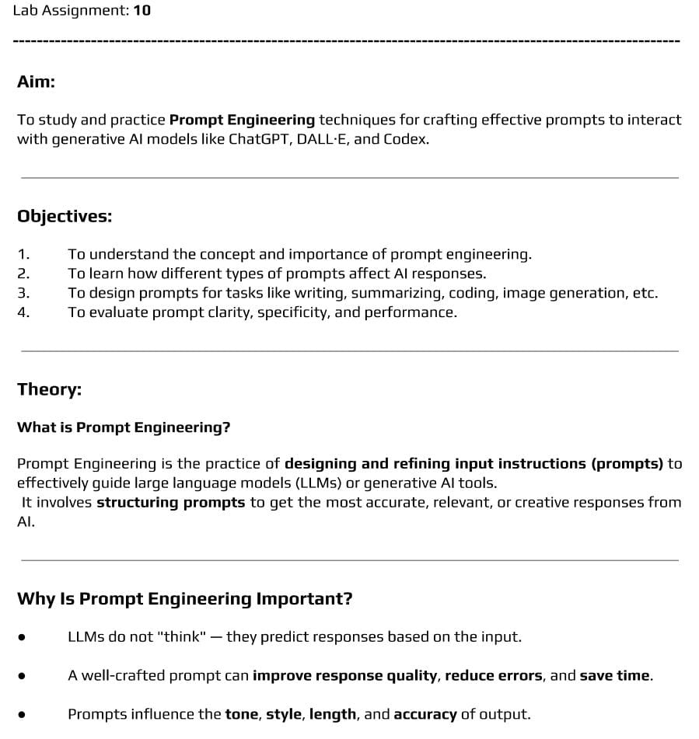

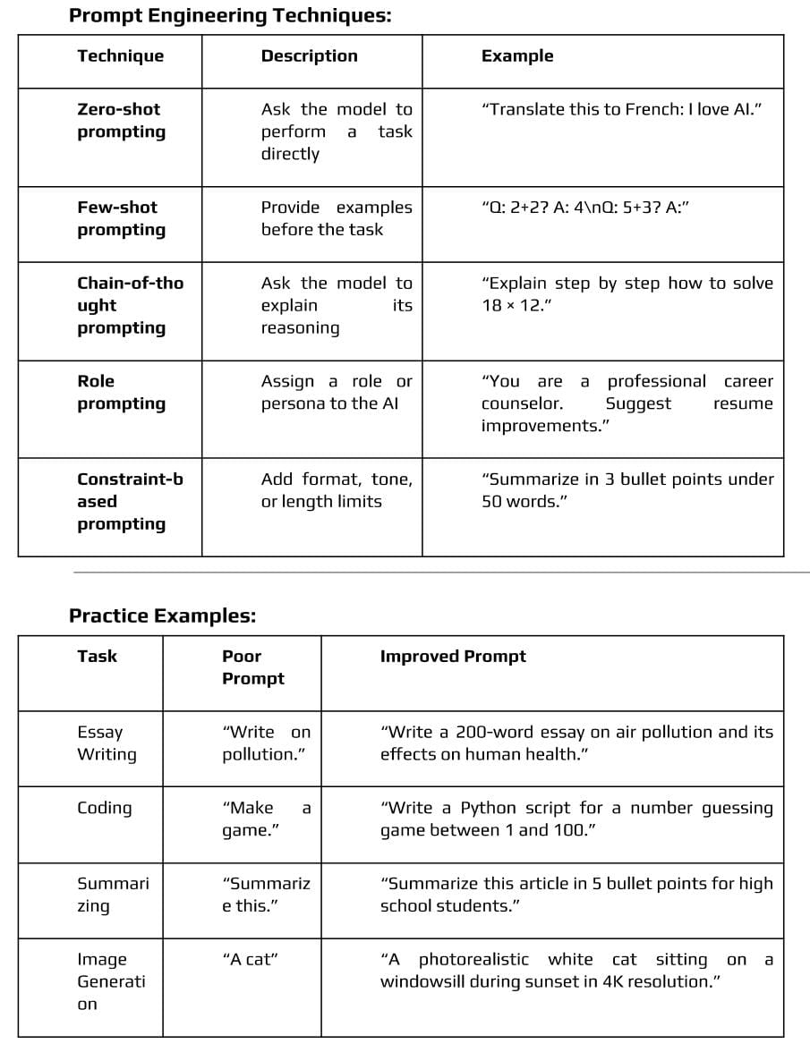
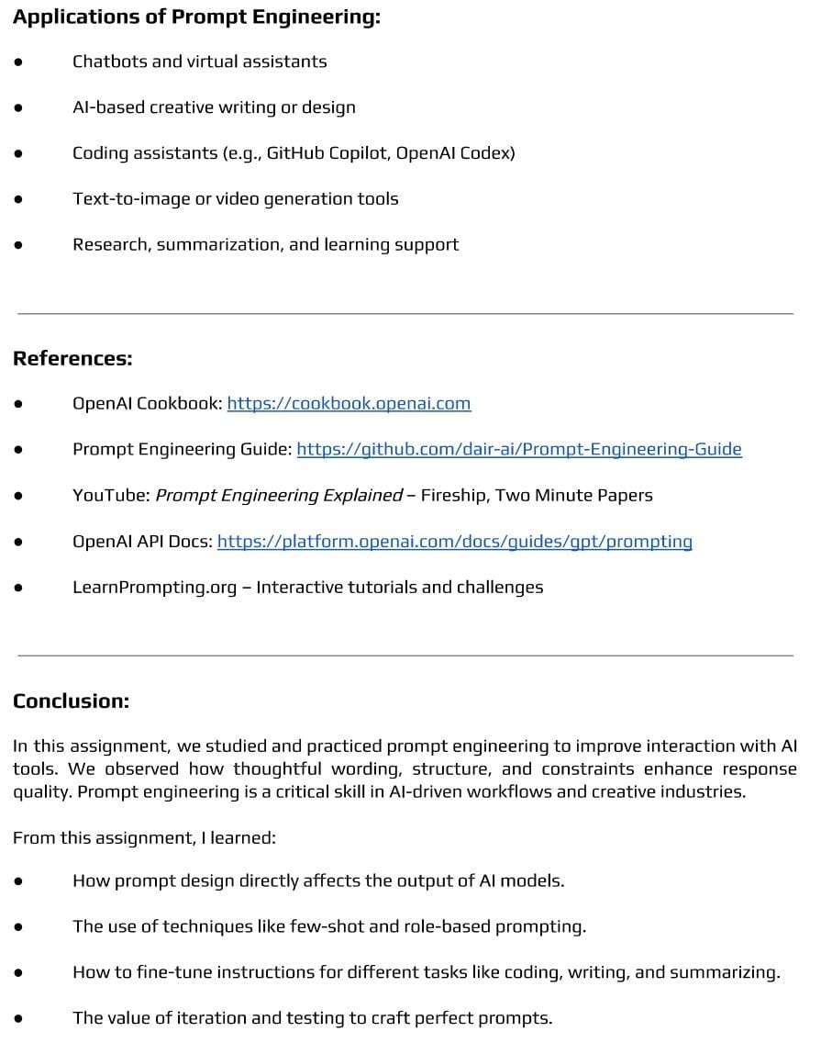
Input:
Prompt:"Explain photosynthesis in simple words for a 10-year-old."
Output:
"Photosynthesis is the process by which plants make their own food using sunlight, water, and carbon dioxide, and they give us oxygen to breathe."
Input:
Bad prmpt: "Write Python code."
Output:
"print('Hello')"
Input:
Good prompt:"Write a Python function to check if a number is prime."
Output:
"def is_prime(n):\n if n < 2: return False\n for i in range(2, int(n**0.5)+1):\n if n % i == 0:\n return False\n return True"
Conclusion:
Outcome:
Upon completion of this experiment, students will be able to:
ELO1: Create clear and well-structured prompts that help AI tools give accurate and useful responses.
ELO2: Use different prompt techniques—such as role prompts, examples, and step-by-step instructions—to improve the quality of AI-generated output.
ELO3: Test and refine prompts by checking how the AI responds, adjusting the wording, and making the prompts more effective for different tasks.
Questions:
- What is prompt engineering in AI?
- Why is prompt engineering important for AI models like ChatGPT?
- What is a “prompt” in the context of AI?
- Give one example of a well-crafted prompt.
- How can prompt engineering improve AI output quality?

Appendix

- Common AI Terminology
Term | Description
Expert System | AI program that uses knowledge and rules to make decisions.
BFS (Breadth-First Search) | Graph traversal algorithm that explores all neighbors before moving to the next level.
DFS (Depth-First Search) | Graph traversal algorithm that explores as deep as possible before backtracking.
A* Algorithm | Heuristic search algorithm that finds the shortest path using f(n) = g(n) + h(n).
CSP (Constraint Satisfaction Problem) | Problem-solving framework where variables must satisfy given constraints.
Minimax Algorithm | Algorithm used in two-player games to maximize the player’s minimum gain.
Alpha-Beta Pruning | Optimization for Minimax that reduces nodes evaluated without changing the outcome.
ChatGPT | AI language model used for text generation and interactive tasks.
SORA | AI tool used for generating videos from text prompts.
AI Image Generator | AI system that generates images from textual descriptions.
Prompt Engineering | Crafting precise instructions to guide AI models for better outputs.

- Sample Inputs and Outputs
Practical | Sample Input | Sample Output
Expert System | “Patient has fever and headache” | “Possible disease: Dengue”
BFS & DFS | Maze graph with start = A, goal = F | BFS path: A → B → C → F, DFS path: A → D → F
A* Algorithm | Start: S, Goal: G, Heuristic h(n) | Shortest path: S → A → G, cost = 5
CSP | Map coloring: Regions {A, B, C}, Colors {Red, Green} | A = Red, B = Green, C = Red
Minimax | Tic-Tac-Toe board state | Optimal move: Place X at (2,2)
Alpha-Beta Pruning | Game tree with leaf nodes [3,5,2,9] | Optimal value: 3, Node 9 pruned
ChatGPT | “Explain BFS in simple terms” | “BFS explores all neighboring nodes before moving deeper…”
SORA | “Create a video of a cat playing with a ball” | Short video showing a cat playing in a garden
AI Image Generator | “A futuristic city at sunset” | AI-generated image of city skyline with neon lights
Prompt Engineering | “Summarize the article in 3 points” | Bullet points summarizing the article
- Common Formulas / Concepts
A* Evaluation Function:
f(n)=g(n)+h(n)
g(n) = cost from start to node n
h(n)= heuristic estimate from n to goal
Minimax Algorithm:
MAX node: chooses highest value
MIN node: chooses lowest value
Alpha-Beta Pruning:
Alpha (α\alphaα) = best value MAX can guarantee
Beta (β\betaβ) = best value MIN can guarantee
Prunes branches where α≥β\alpha \geq \betaα≥β
CSP – Constraint Propagation:
Eliminates values that violate constraints to reduce search space.

- Diagrams
1. BFS vs DFS (Maze)
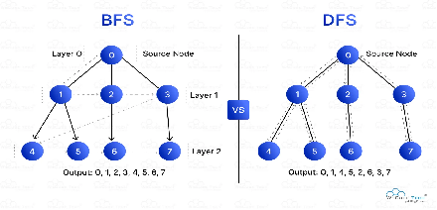
2 .Minimax + Alpha-Beta
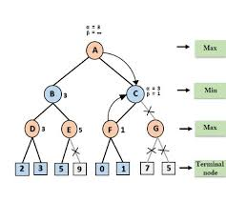
3. A* algorithm
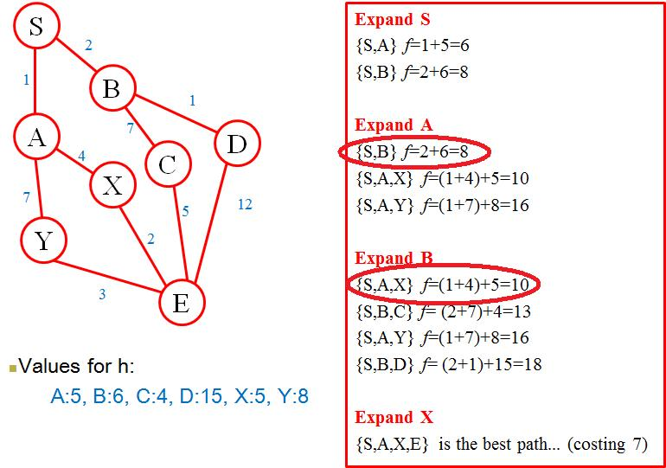
4 . Constraint Satisfaction Problem
